**Section 11: Web Servers**

This entire section of the security requirements is applicable if the UDR supports a web **management interface**.

**2.11.1 HTTPS**

Requirement:

**The communication between UDR Web client and UDR Web server shall be protected strictly using the Secure cryptographic controls prescribed in Table 1 of the latest document “ITSAR for Cryptographic Controls” only.**

[Ref [3]: TSDSI STD T1.3GPP 33.117-17.1.0 V.1.1.0. section **4.2.5.1**]

### 4.2.5 Web Servers

#### ***4.2.5.1*** *HTTPS*

*Requirement Name:* HTTPS

*Requirement Reference:* In accordance with industry best practice

*Requirement Description:* The communication between Web client and Web server shall be protected using TLS. The TLS profile defined in Annex E of TS 33.310 shall be followed with the following modifications:

Cipher suites with NULL encryption shall not be supported

*Threat References*: TR 33.926 [4], clause 5.3.6.8, Insecure Default Configuration

*Test case*:

**Test Name:** HTTPS

**Purpose:** Verify the above requirement.

**Procedure and execution steps, expected results, expected format of evidence:**

These are the same as for the test case in clause **4.2.3.2.4**, except that, for execution step 2, it is tested that NULL encryption is not supported.

##### **4.2.3.2.4** Protecting data and information in transfer

*Requirement Name*: Protecting data and information in transfer

Requirement Reference: In accordance with industry best practice

*Requirement Description*:

- Usage of cryptographically protected network protocols is required.

- The transmission of data with a need of protection shall use industry standard network protocols with sufficient security measures and industry accepted algorithms. In particular, a protocol version without known vulnerabilities or a secure alternative shall be used.

*Threat References:* TR 33.926 [4]*,* clause 5.3.6, Information disclosure

*Test case*:

**Test Name:** TC_PROTECT_DATA_INFO_TRANSFER_1

**Purpose:**

Verify the mechanisms implemented to protect data and information in transfer to and from the Network Product's O&M interface.

NOTE: The test is limited to the O&M interface although the requirement does not have this limitation because the protection of standardised interfaces will be covered by regular interoperability testing and the proprietary use of HTTPS is covered in clause 4.2.5.1.

**Procedure and execution steps:**

**Pre-Conditions:**

Network product documentation containing information about supported O&M protocols is provided by the vendor,

A peer implementing the security protocol configured by the vendor (e.g SSH client supporting SSHv2 or HTTPS client) shall be available.

Network product documentation stating which security protocols for protection of data in transit are implemented and which profiles in TS 33.310 [9] and TS 33.210 [15] are applicable is provided by the vendor

For TLS/DTLS, the tester shall base the tests on the profile defined by 3GPP in TS 33.310 [9] and TS 33.210 [15]. For IKE and IPsec, the tester shall base the tests on the profile defined by 3GPP in TS 33.210 [15]. For protocols, for which 3GPP did not define a security profile, e.g. SSH, the tester shall base the tests on a widely recognised and publicly available security profile (e.g., security profile defined by IETF or NIST).

**Execution Steps**

1. The tester shall check that compliance with the selected security profile can be inferred from detailed provisions in the product documentation.

2. The tester shall check that the default security parameters are the same as those stated in the product documentation.

3. The tester shall establish a secure connection between the network product and the peer and verify that all protocol versions and combinations of cryptographic algorithms that are mandated by the security profile are supported by the network product and the network product does not use the deprecated or unsecure protocol versions and algorithms.

4. The tester shall try to establish a secure connection between the network product and the peer and verify that this is not possible when the peer only offers a feature, including protocol version and combination of cryptographic algorithms, that is forbidden by the security profile.

**Expected Results:**

The traffic is properly protected, and insecure options are not accepted by the Network Product.

**Expected format of evidence:**

Provide evidence of the check of the product documentation in plain text. Save the logs and the communication flow in a **.pcap file.**

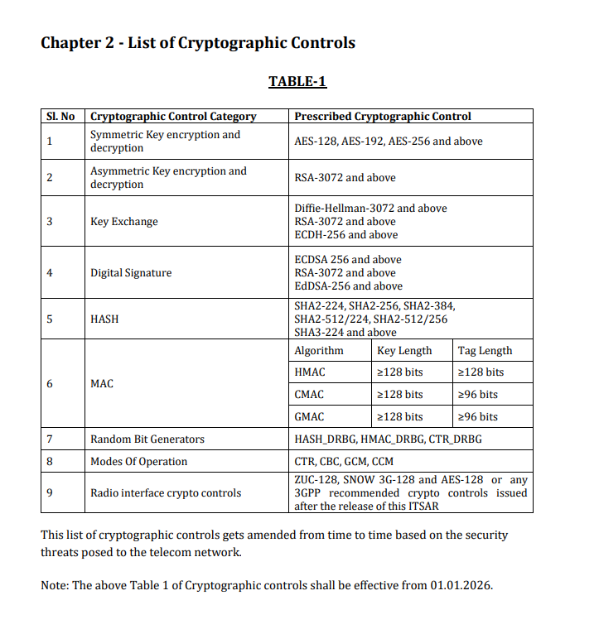

First we are going to get the Hardware Detail (Processor information, Processor Model

Number , Vendor details, Cache information) and the OS related information.

Execute the shell script **check5gcudr_1** to get the hardware details (Processor information,

Processor Model number, Vendor details, Cache information) and the OS related information.

**$ cat check5gcudr_1.sh**

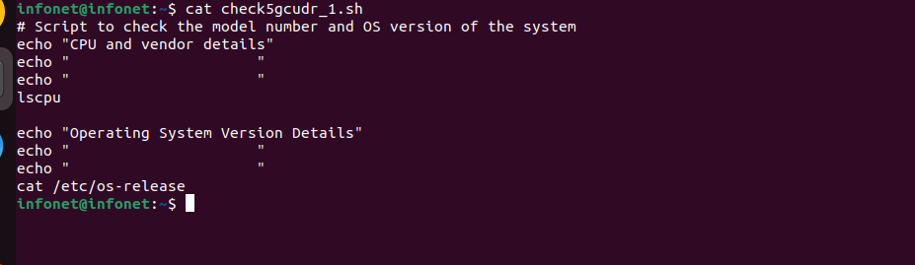

Fig **1: Script to display CPU and OS details**

The lscpu command in the above script will display all the details related to:

i) CPU

ii) Architecture

iii) Vendor ID

iv) Model Name

v) Virtualization Features and cache details.

The **cat /etc/os-release** command in the script will display:

i) OS name

ii) version number and

iii) version ID details

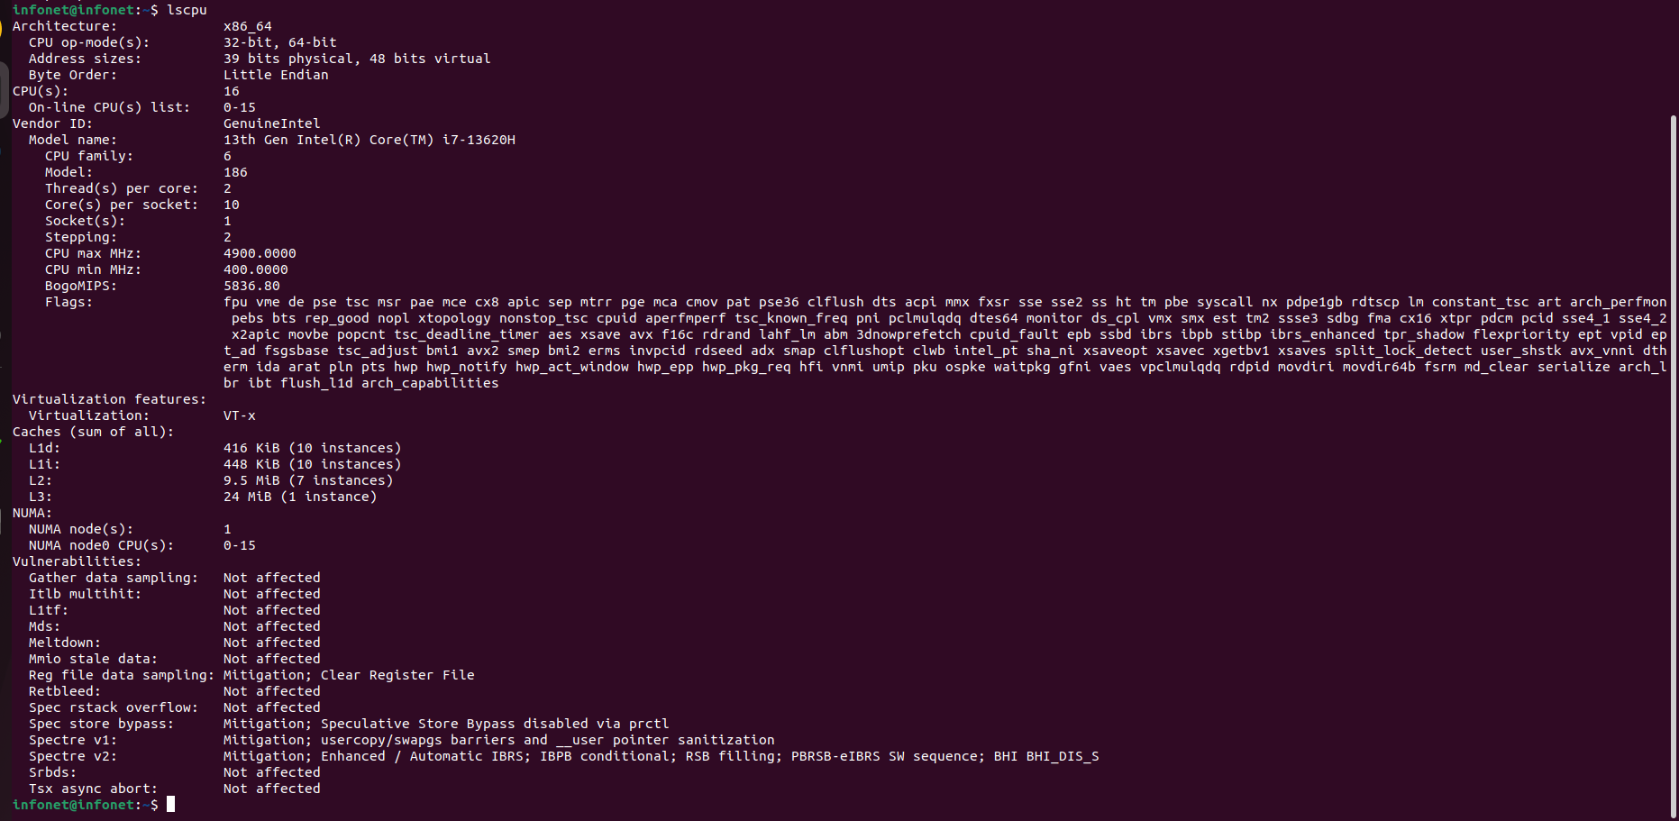

**Fig. 2 Output screen displaying the hardware-CPU details**

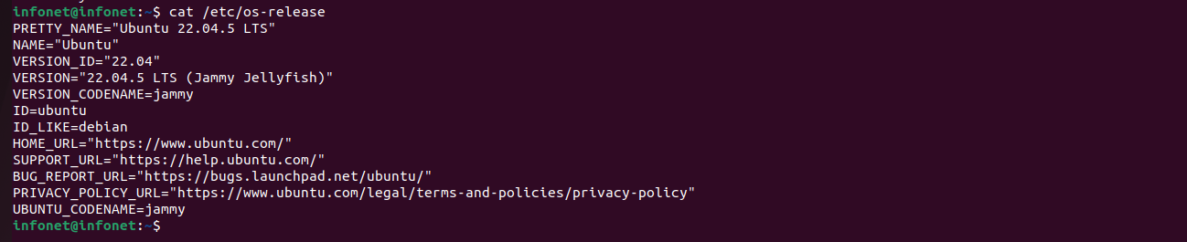

**Fig. 3 Output screen displaying the CPU and OS details**

**If the UDR NF is containerized in a docker, then**

Obtain the license and software version details as well as the hash value of the UDR NF by executing the command

**$ docker images --digests | grep "oai-udr"**

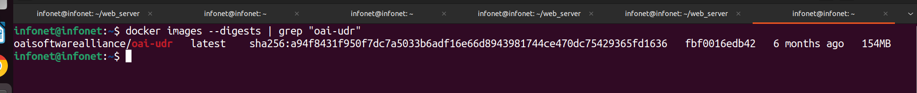

**Fig. 4 Command and Output screen displaying the UDR NF details**

1. Obtain the hash of the UDR configuration file by executing the command

**$ sha256 udr.conf.**

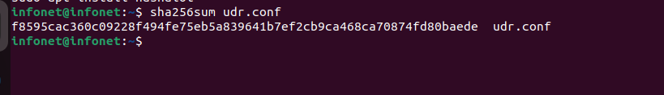

**Fig. 5 : Command and Output screen displaying the software checksum of the UDR configuration file.**

For Obtain all possible software checksums of the UDR NF by executing the script **check_5gcudr_2.**

**$ cat check_5gcudr_2.sh**

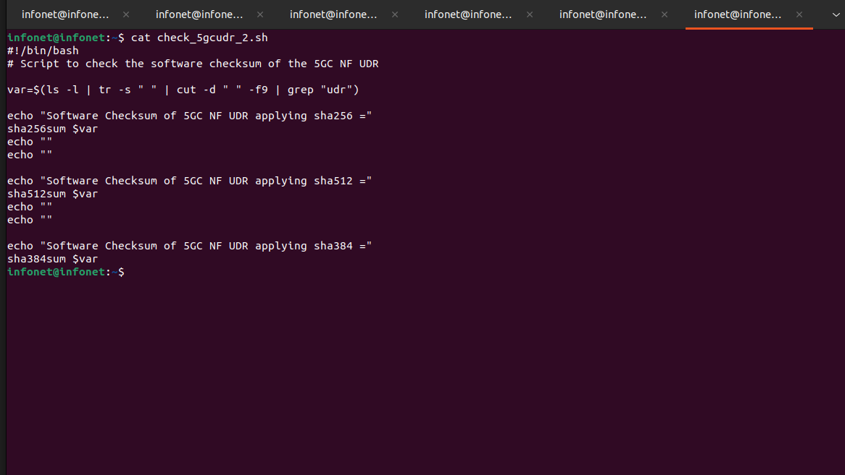

**Fig. 6 Script to apply software checksums of NF UDR**

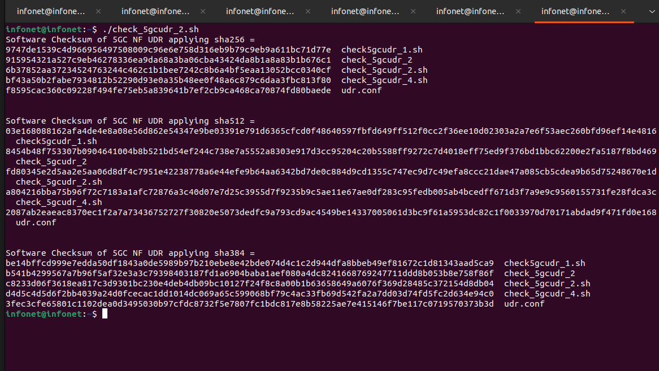

**Fig. 7 Output screen displaying the software checksum of UDR NF.**

**5. DUT Configuration:**

To obtain the Device under Test configuration and installed utilities related information, execute the script check_5gcudr_4.

The script uses the commands **ifconfig**, **dpkg** **-l** and **cat /etc/udr.conf** to list all the network interfaces along with IP addresses, list all software packages involved and the UDR NF configuration.

**$sh check_5gcudr_4**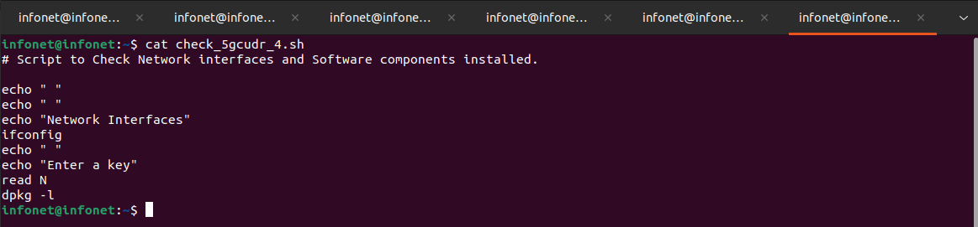

**Fig. 8 Script to display all network interfaces and software packages installed**

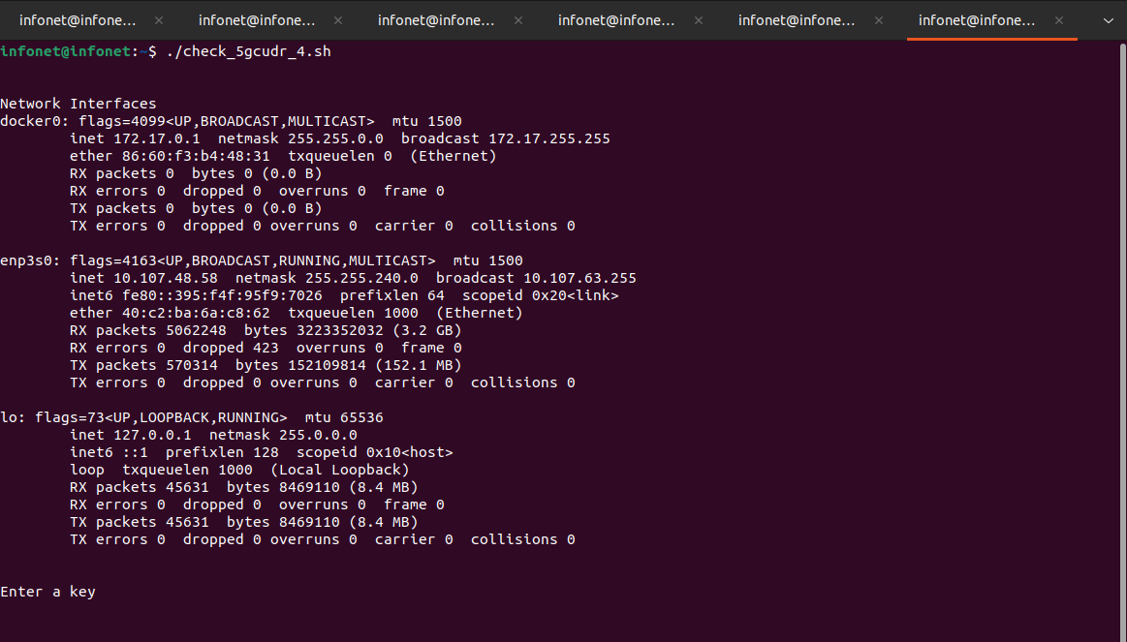

**Fig. 9 Output screen displaying the Network Interfaces**

**$ cat /etc/udr.conf**

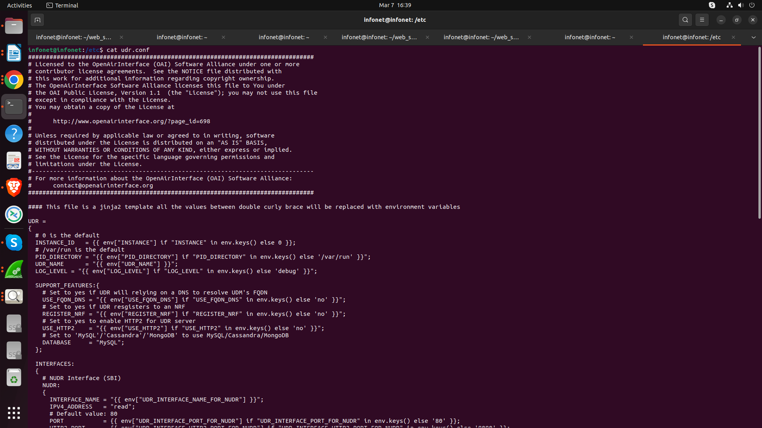

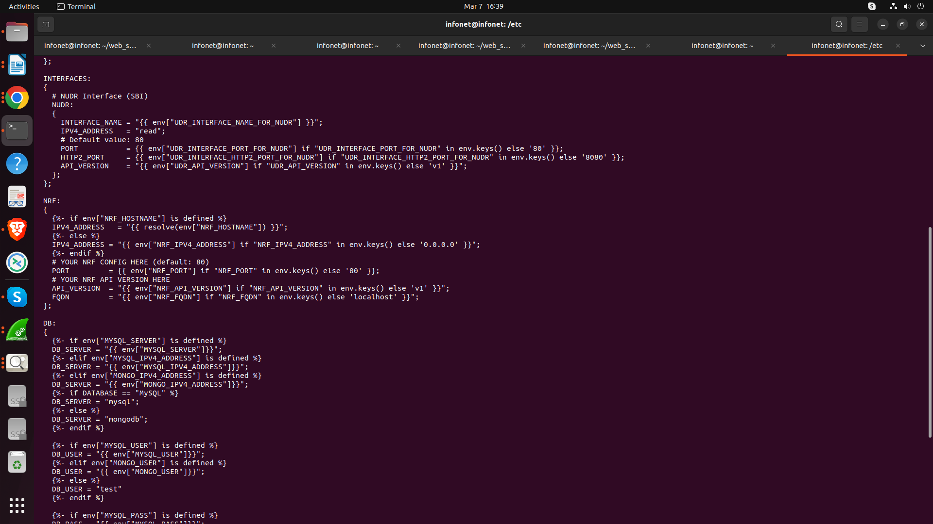

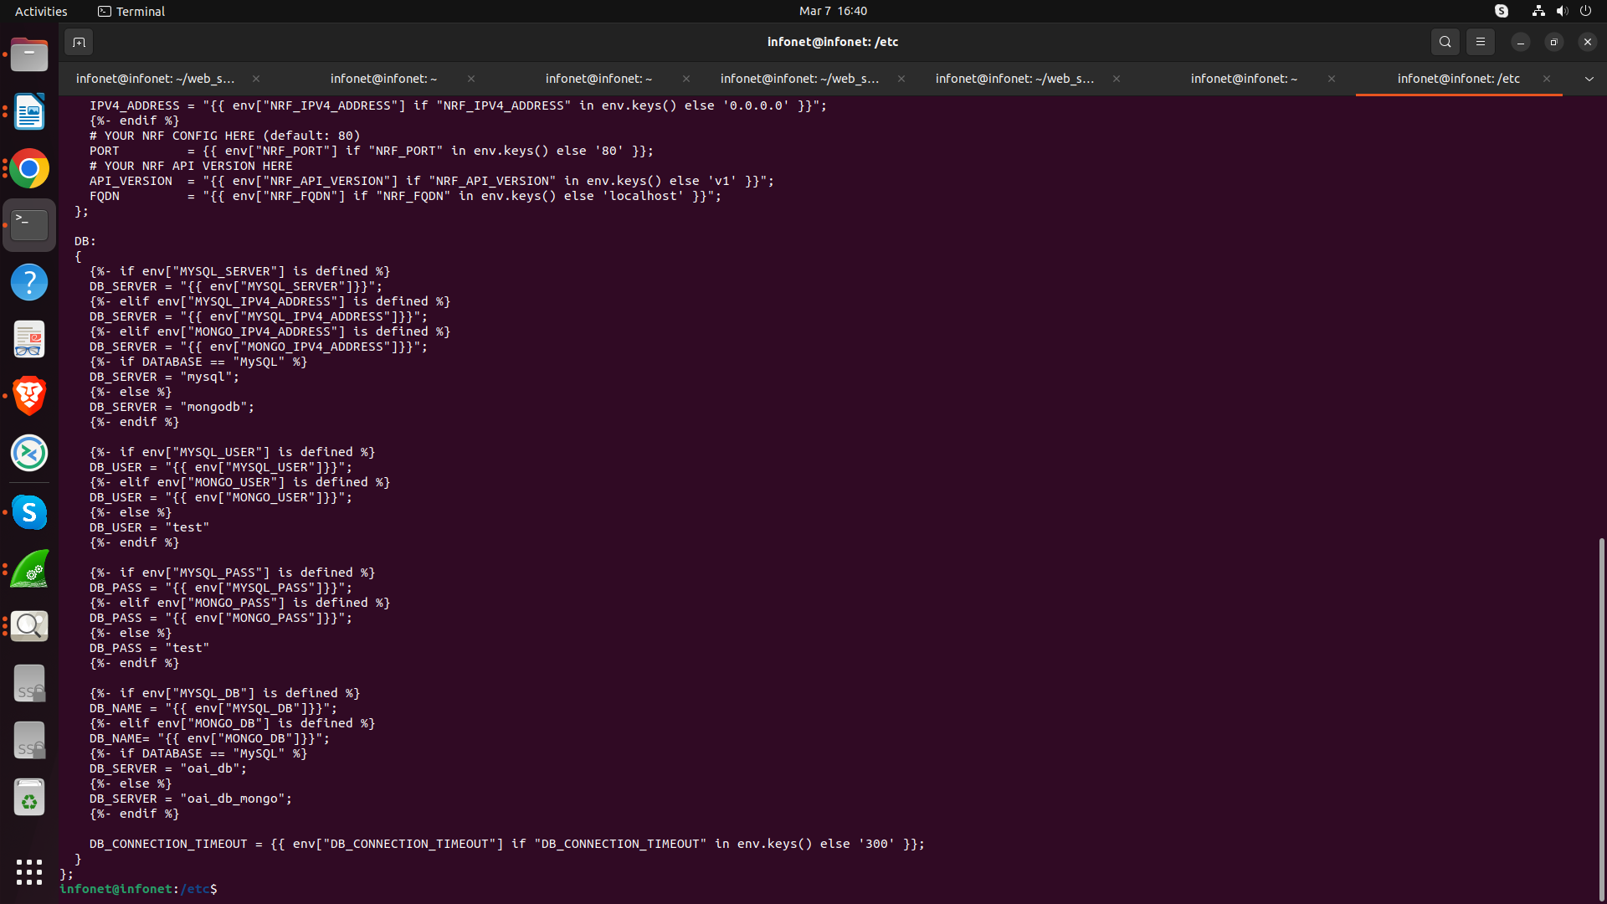

**Fig. 11 Output screen displaying the udr.conf file of the /etc directory**

4.2.3.2.4

Protecting data and information in transfer

Requirement Name: Protecting data and information in transfer

Requirement Reference: In accordance with industry best practice

Requirement Description:

-Usage of cryptographically protected network protocols is required.

-The transmission of data with a need of protection shall use industry standard network protocols with sufficient security measures and industry accepted algorithms. In particular, a protocol version without known vulnerabilities or a secure alternative shall be used.

Threat References: TR 33.926 [4], clause 5.3.6, Information disclosure

Test case:

Test Name: TC_PROTECT_DATA_INFO_TRANSFER_1

Purpose:

Verify the mechanisms implemented to protect data and information in transfer to and from the Network Product's

O&M interface.

NOTE:

The test is limited to the O&M interface although the requirement does not have this limitation because the protection of standardised interfaces will be covered by regular interoperability testing and the proprietary use of HTTPS is covered in clause 4.2.5.1.

Procedure and execution steps:

Pre-Conditions:

Network product documentation containing information about supported O&M protocols is provided by the vendor, a peer implementing the security protocol configured by the vendor (e.g SSH client supporting SSHv2 or HTTPS client) shall be available.

Network product documentation stating which security protocols for protection of data in transit are implemented and which profiles in TS 33.310 [9] and TS 33.210 [15] are applicable is provided by the vendor.

For TLS/DTLS, the tester shall base the tests on the profile defined by 3GPP in TS 33.310 [9] and TS 33.210 [15]. For IKE and IPsec, the tester shall base the tests on the profile defined by 3GPP in TS 33.210 [15]. For protocols, for which 3GPP did not define a security profile, e.g. SSH, the tester shall base the tests on a widely recognised and publicly available security profile (e.g., security profile defined by IETF or NIST).

Execution Steps

1. The tester shall check that compliance with the selected security profile can be inferred from detailed

provisions in the product documentation.

2. The tester shall check that the default security parameters are the same as those stated in the product

documentation.

3. The tester shall establish a secure connection between the network product and the peer and verify that all protocol versions and combinations of cryptographic algorithms that are mandated by the security profile are supported by the network product and the network product does not use the deprecated or unsecure protocol versions and algorithms.

4. The tester shall try to establish a secure connection between the network product and the peer and verify that this is not possible when the peer only offers a feature, including protocol version and combination of cryptographic algorithms, that is forbidden by the security profile.

Expected Results:

The traffic is properly protected, and insecure options are not accepted by the Network Product.

Expected format of evidence:

Provide evidence of the check of the product documentation in plain text. Save the logs and the communication flow in a .pcap file.

**Execute the commands: ‘sudo mysql -u root -p’**

Mysql> Show Databases;

Mysql>Use dummydb;

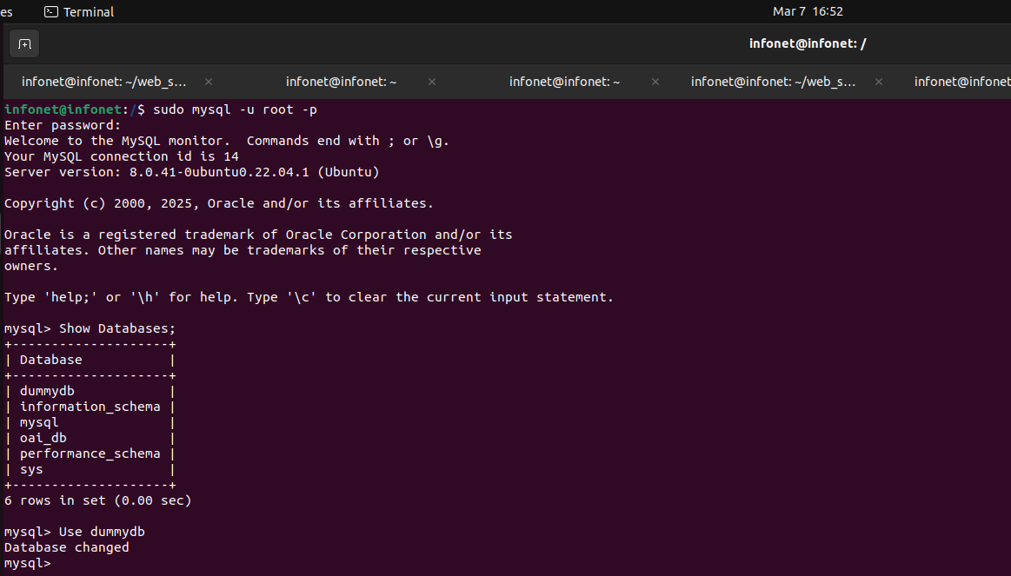



**Fig. 14 The screen output displays the databases of UDR NF.**

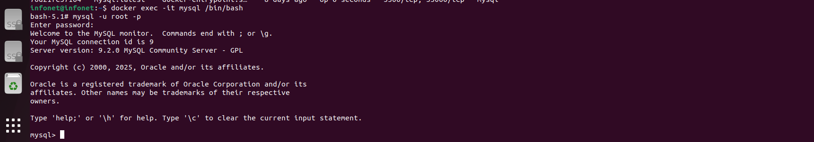

**Fig .13 The screen output displays the ssh login of the server, use ‘docker ps-a’ to check all container health, use command ‘docker exec -it mysql /bin/bash’ login mysql database and the databases of UDR NF.**

1. To verify authentication mechanisms have been configured on the UDR NF

Look for the have_ssl and have_openssl values:

* 1. If they are set to YES, SSL is already enabled.
  2. If they are set to DISABLED, SSL is either not configured or the UDR database installation lacks SSL support.

Execute the commands: SHOW VARIABLES LIKE '%SSL%';

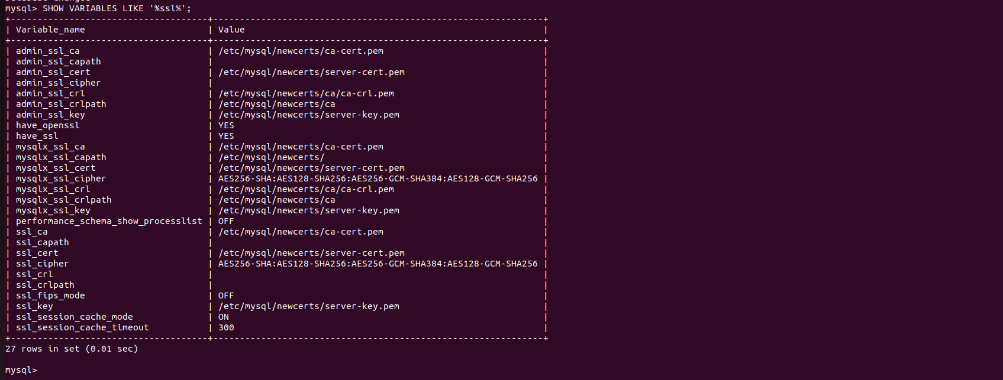

**Fig. 15 The screen output displays have_openssl and have_ssl value ‘set YES’ and ssl_ca, ssl_cert and ssl_key value configuration of UDR NF database server.**

1. Execute the commands: ‘ls -la’ to verify access right of certificate and key on server.

Mutual Authentication on UDR Database using SSL protocol

Explanation:

1. SSL Certificates explanation:
   * CA Certificate: Generated as the root Certificate Authority (CA) for mutual authentication.
   * Server Certificate: The server uses this certificate to prove its identity to clients.
   * Client Certificate: The client uses this certificate to prove its identity to the server.

**Create a Secure Directory for Certificates**

bash

CopyEdit

sudo mkdir -p /etc/mysql/newcerts

sudo chmod 700 /etc/mysql/newcerts

cd /etc/mysql/newcerts

This directory will hold your CA, server, and client certificates/keys.

## 2. Generate a CA (Certificate Authority) Key and Certificate

1. **Generate the CA key (RSA-3072 bits)**

sudo openssl genrsa -out ca-key.pem 3072

1. **Create a self-signed CA certificate using SHA-256**

sudo openssl req -x509 -new -nodes -sha256 \

-key ca-key.pem \

-days 365 \

-out ca-cert.pem \

-subj "/C=IN/ST=YourState/L=YourCity/O=YourOrg/OU=IT/CN=MyRootCA"

## 3. Generate the Server Key and Certificate

1. **Generate the server key (RSA-3072 bits)**

sudo openssl genrsa -out server-key.pem 3072

1. **Create a Certificate Signing Request (CSR)**

sudo openssl req -new -sha256 \

-key server-key.pem \

-out server-req.pem \

-subj "/C=IN/ST=YourState/L=YourCity/O=YourOrg/OU=IT/CN=server.local"

1. **Sign the Server CSR with the CA**

sudo openssl x509 -req -in server-req.pem -sha256 \

-CA ca-cert.pem -CAkey ca-key.pem -CAcreateserial \

-out server-cert.pem -days 365

This produces **server-cert.pem** signed by **ca-cert.pem**.

1. **Secure Permissions**

sudo chown mysql:mysql server-key.pem server-cert.pem ca-cert.pem

sudo chmod 600 server-key.pem

## 4. Generate the Client Key and Certificate (for Mutual TLS)

1. **Generate the client key (RSA-3072 bits)**

sudo openssl genrsa -out client-key.pem 3072

1. **Create a Client CSR**

sudo openssl req -new -sha256 \

-key client-key.pem \

-out client-req.pem \

-subj "/C=IN/ST=YourState/L=YourCity/O=YourOrg/OU=IT/CN=client.local"

1. **Sign the Client CSR with the CA**

sudo openssl x509 -req -in client-req.pem -sha256 \

-CA ca-cert.pem -CAkey ca-key.pem -CAcreateserial \

-out client-cert.pem -days 365

1. **Secure Permissions**

sudo chown mysql:mysql client-key.pem client-cert.pem

sudo chmod 600 client-key.pem

After these steps, you should have:

* **ca-cert.pem** (CA certificate)
* **ca-key.pem** (CA private key)
* **server-cert.pem** (server certificate)
* **server-key.pem** (server private key)
* **client-cert.pem** (client certificate)
* **client-key.pem** (client private key)

## 5. Configure MySQL to Use SSL/TLS

Edit MySQL’s configuration file, typically at /etc/mysql/mysql.conf.d/mysqld.cnf (or /etc/my.cnf on some distributions). Under the [mysqld] section, add:

[mysqld]

ssl-ca = /etc/mysql/newcerts/ca-cert.pem

ssl-cert = /etc/mysql/newcerts/server-cert.pem

ssl-key = /etc/mysql/newcerts/server-key.pem

# admin_ssl_ca = /etc/mysql/newcerts/ca-cert.pem

# admin_ssl_cert = /etc/mysql/newcerts/server-cert.pem

# admin_ssl_key = /etc/mysql/newcerts/server-key.pem

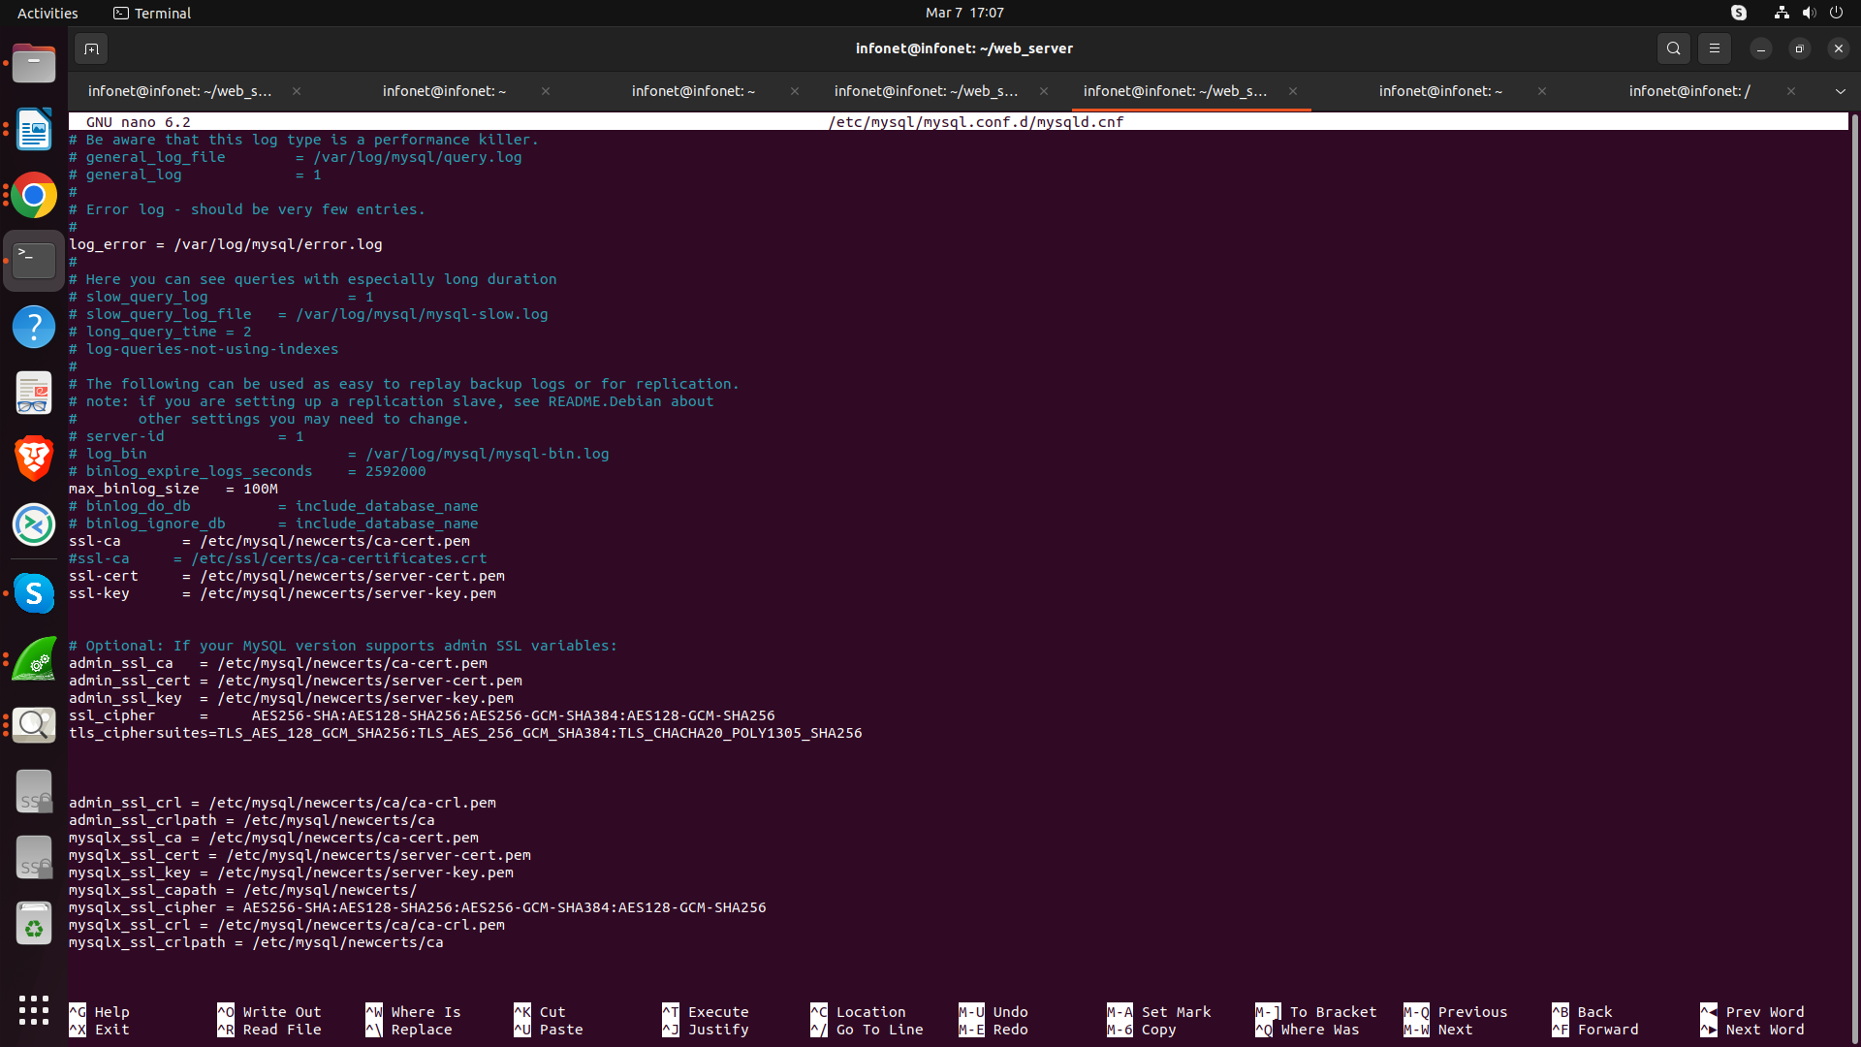

Then **restart MySQL**:

sudo systemctl restart mysql

## 6. Verify the SSL/TLS Configuration

Log into MySQL and run:

SHOW VARIABLES LIKE '%ssl%';

You should see:

* **have_ssl** and **have_openssl** = **YES**
* **ssl_ca**, **ssl_cert**, **ssl_key** pointing to /etc/mysql/newcerts/…



sudo ls -ld /etc/mysql/newcerts

You should see something like:

drwxr-xr-x 2 mysql mysql 4096 Feb 27 11:49 /etc/mysql/newcerts

If the permissions aren’t set to at least 755, then the mysql user might not be able to read the directory.

1. **Change the owner of the directory to mysql (if not already):**

sudo chown mysql:mysql /etc/mysql/newcerts

1. **Set the directory permissions so that it’s world-readable (755):**

sudo chmod 755 /etc/mysql/newcerts

1. **Verify the changes:**

sudo ls -ld /etc/mysql/newcerts

The output should now show permissions like drwxr-xr-x with owner and group set to mysql.

After these changes, MySQL should be able to read the certificate files in that directory. Restart MySQL afterward:

sudo systemctl restart mysql

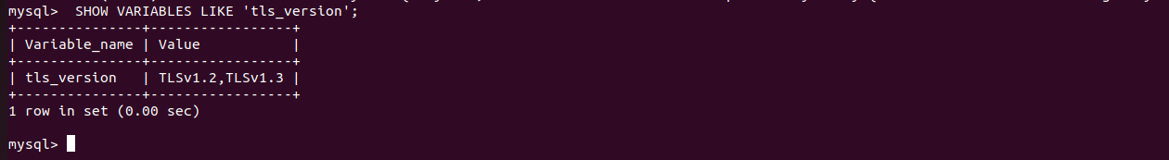

**Fig. 16 The screen output displays CA certificate and key for server, client and their access rights in database server. For executing commands “SHOW VARIABLES LIKES ‘tls_version’ to get TLS version details TLS_version TLSv1.2, TLSv1.3 in the database.**

To verify key exchange algorithm **RSA-3072 bit on the UDR NF**

Execute the commands:

**$ openssl pkey -in /etc/mysql/newcerts/server-key.pem -text -noout**

to verify RSA encryption(RSA-3072 bit). This confirms if the private key is valid and displays its modulus.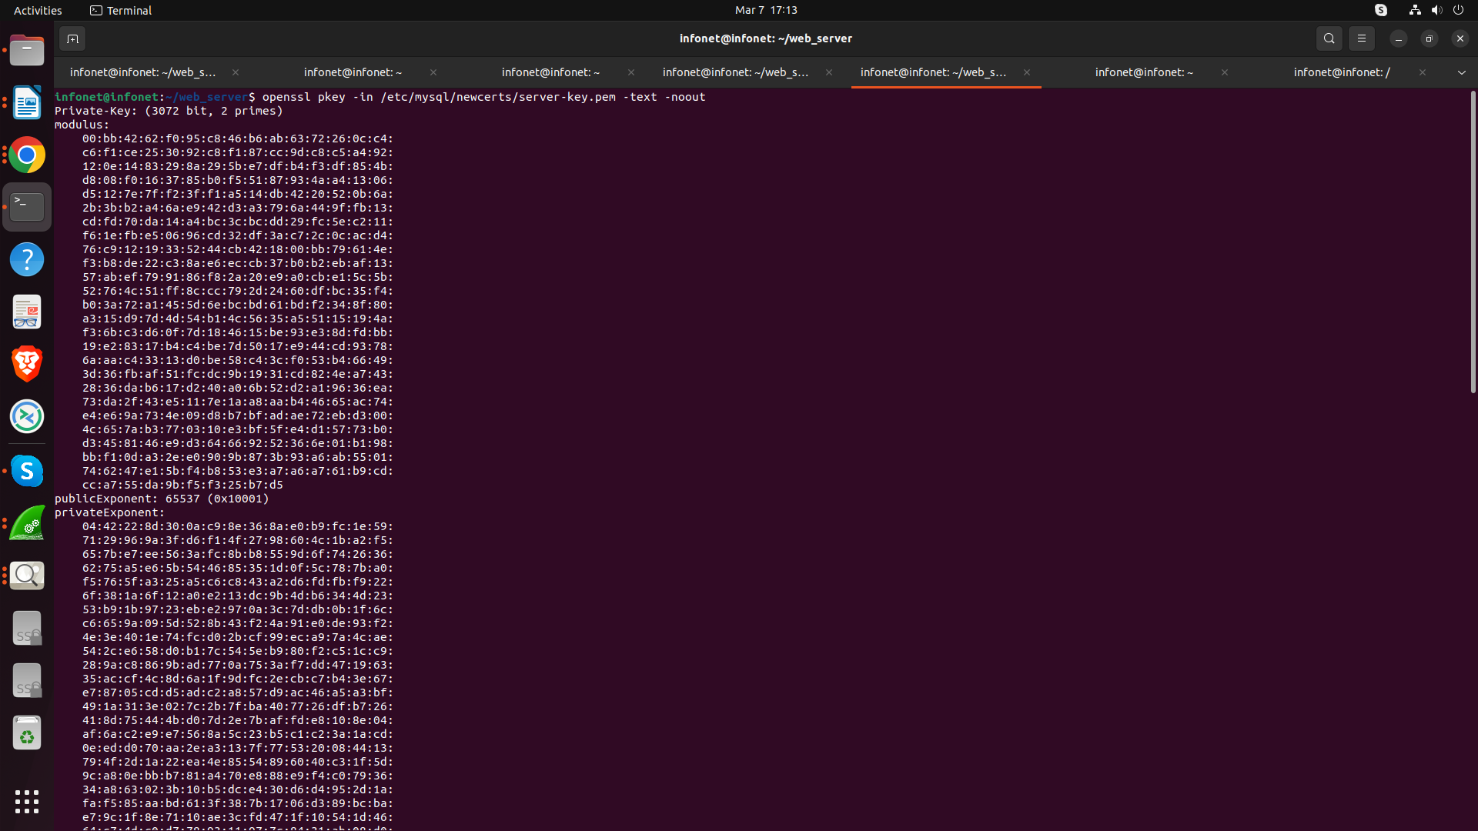

**Fig .17 :The screen output examines server-key.pem using RSA-3072 bits showing their modulus and exponent .ITSAR number ‘ITSAR001962411’, ITSAR name NCCS/ITSAR/Standards Applicable for Group of Equipment/Cryptographic Controls/Cryptographic Controls (Applicable to all ITSARs) and version 2.0.0.**

c) To verify certificate rsa encryption **RSA-3072 bit on the UDR NF**

Execute the commands:

$ **openssl x509 -in /etc/mysql/newcerts/client-cert.pem -text -noout**

to verify RSA encryption (RSA-3072 bit). This displays the certificate details, including its issuer, validity period, and subject.

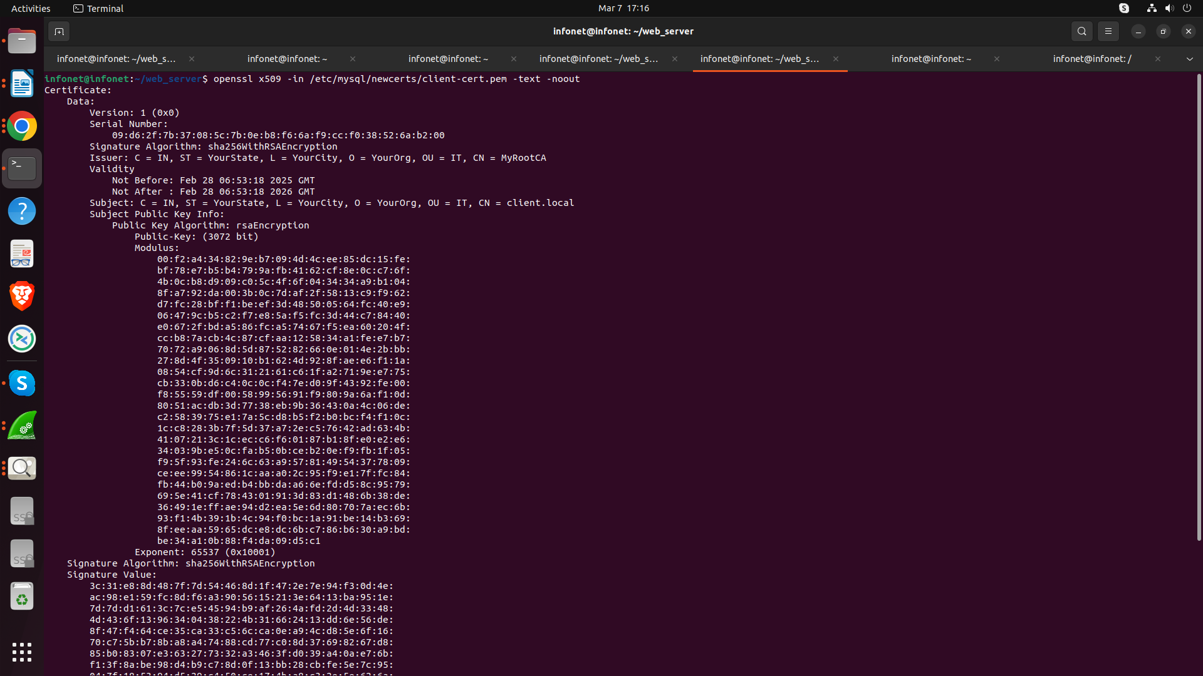

**Fig. 18 The screen output examines certificate details, including its issuer, validity period, and subject of client-cert.pem. . ITSAR number ‘ITSAR001962411’, ITSAR name NCCS/ITSAR/Standards Applicable for Group of Equipment/Cryptographic Controls/Cryptographic Controls (Applicable to all ITSARs) and version 2.0.0.**

ii) Execute the commands: ‘ls -la’ to verify access right of certificate and key on client system.

**Execute the command on client system Tester folder:**

**$ mysql -u user2 -p -h 10.107.48.58 --ssl-ca=/home/infonet/ssl/ca-cert.pem --ssl-cert=/home/infonet/ssl/client-cert.pem --ssl-key=/home/infonet/ssl/client-key.pem**

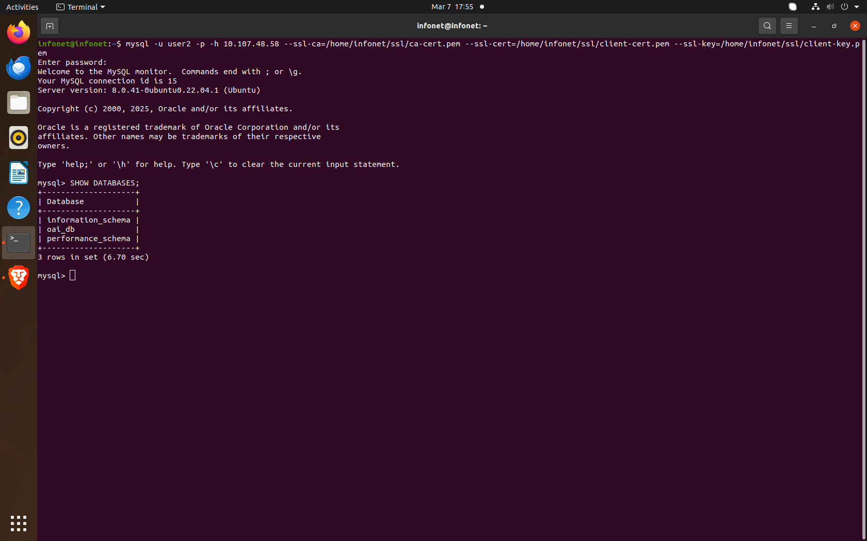

**Fig. 19 The screen output displays CA certificate and key for Client and their access rights in client system. The tester triggers communication between the UDR NF database server and a client system that doesn't have a legitimate authentication credential that shows access denied for user and client with correct credentials can be established connection with the server.**

Coming to Web server part we have use **Node.js**  to make a server on   
http://10.107.48.58:3000 and [**https://localhost:3000**](http://localhost:3000) **and** [**https://10.107.48.58:3000**](https://10.107.48.58:3000)

iii) Execute the commands: **‘node app.js’** and verify the server running status and connection with http/https over SSL/TLS.

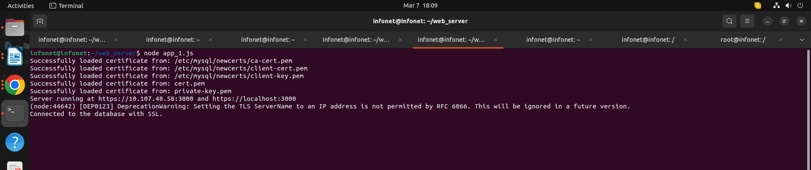

**Fig. 20 The screen output displays the server running on localhost port 3000 and connected**

**to the database with http/https over SSL/TLS.**

iv) Verify the server running on localhost port **3000** and connect to the database with SSL in the web browser. Login interface will display as shown in figure below.

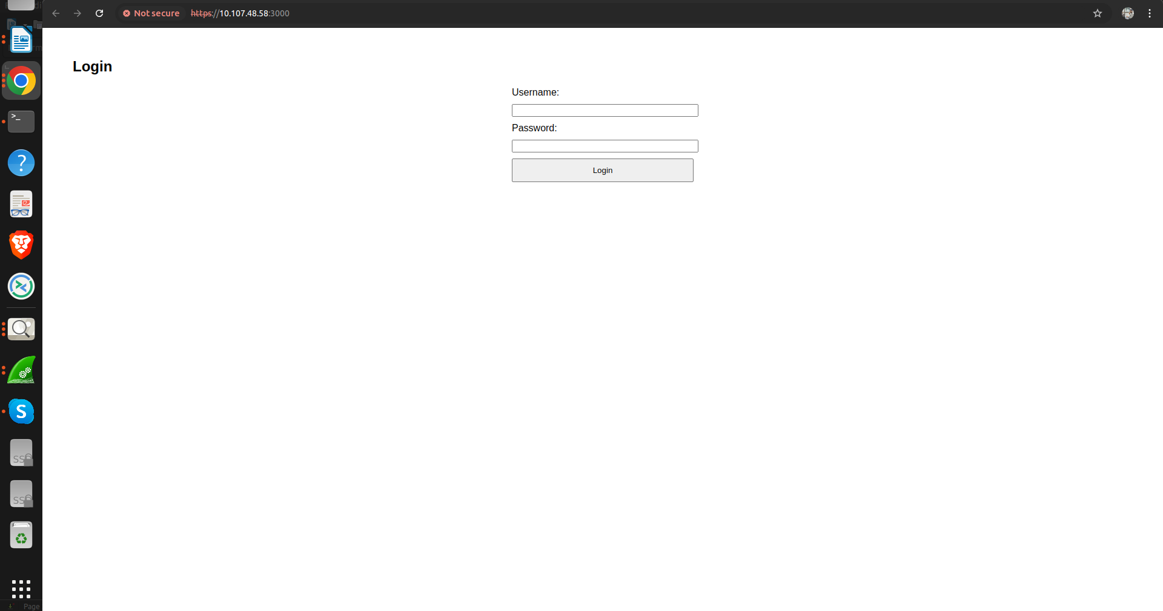

**Fig. 21 The screen output displays the server running on localhost port 3000 and connected**

**to the database with http/https over SSL/TLS in web Browser.**

v) When you enter the correct authentication credentials ‘login successful and welcome, admin’ will be displayed in the browser as shown in figure below. SSL certificate gets verified.

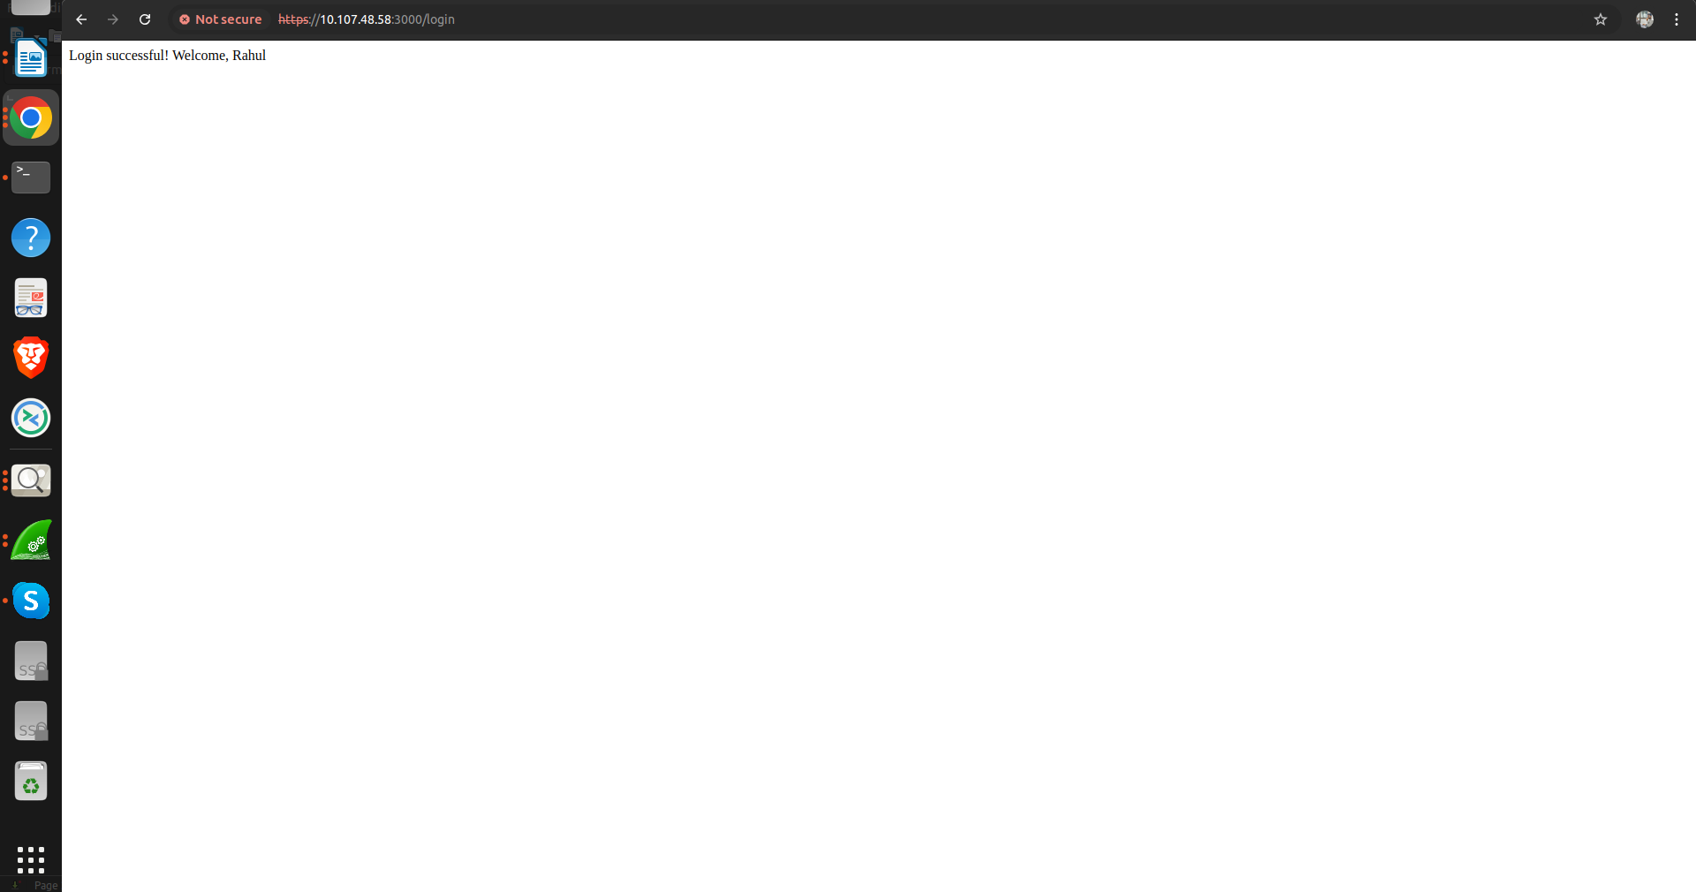

**Fig. 22 The screen output displays the server running on localhost port 3000 and connected to the database with SSL/TLS in web Browser.**

vii) Execute the commands: **‘node server.js’** and verify the server running status and connection with http/https over SSL/TLS.



Fig. 24 The screen output displays the backend starting with **‘node server.js’** the server running on localhost port 5000 and setting the ‘TLS’ serverName with credential user ‘Rahul’ and password '123’.

viii) When you enter the correct authentication credentials ‘Logged in successfully’ will be displayed in the browser as shown in figure below. TLS certificate gets verified.



**Fig. 25 The screen outputs the server login successfully with correct authentication credentials connected to the database with http/https over SSL/TLS in web Browser.**

**ix) When you enter the incorrect authentication credentials ‘Login failed’ will be displayed in the browser as shown in figure below.**

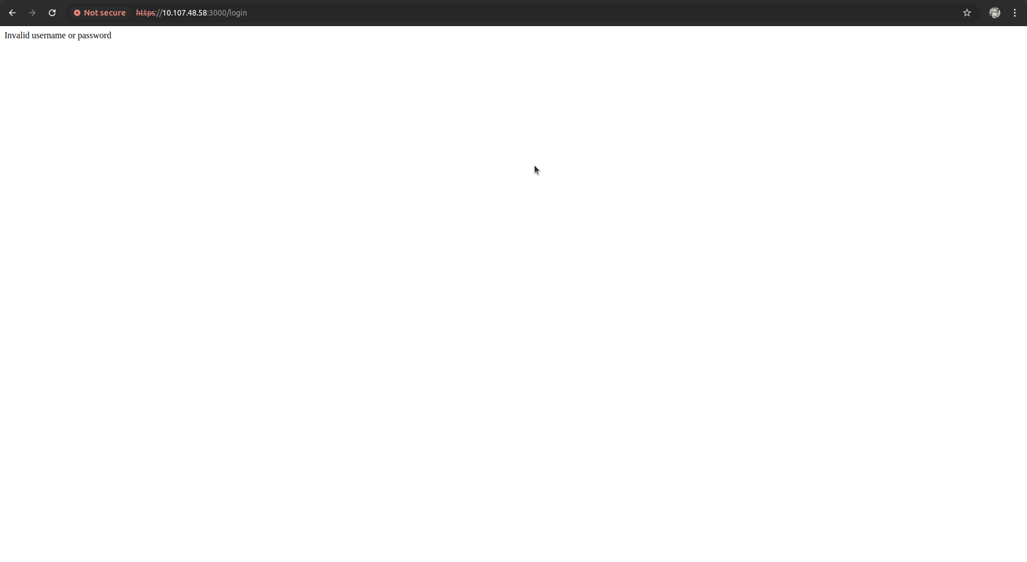

**Fig. 26 The screen outputs the server login failed with incorrect authentication credentials.**

We are using **Ngrok** to expose our local web server to the public internet, allowing anyone from around the world to access it. Ngrok forwards your local server or IP to a publicly assigned domain. However, Ngrok is intended only for testing purposes. For development or production use, **it's recommended to use services like AWS or any other hosting provider to host your server publicly**

Run below command in your terminal :

**$ ngrok http** [**https://localhost:3000**](https://localhost:3000)

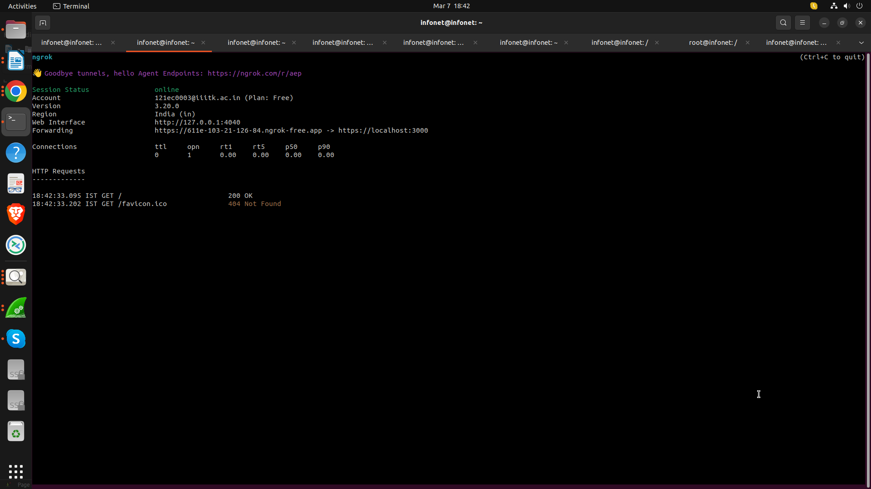

**Fig. 27 The screen outputs after running the Ngrok server on my localhost which assigned one public domain which is accessible from anywhere**

**We can also verify the** [**https://611e-103-21-126-84.ngrok-free.app/**](https://611e-103-21-126-84.ngrok-free.app/)

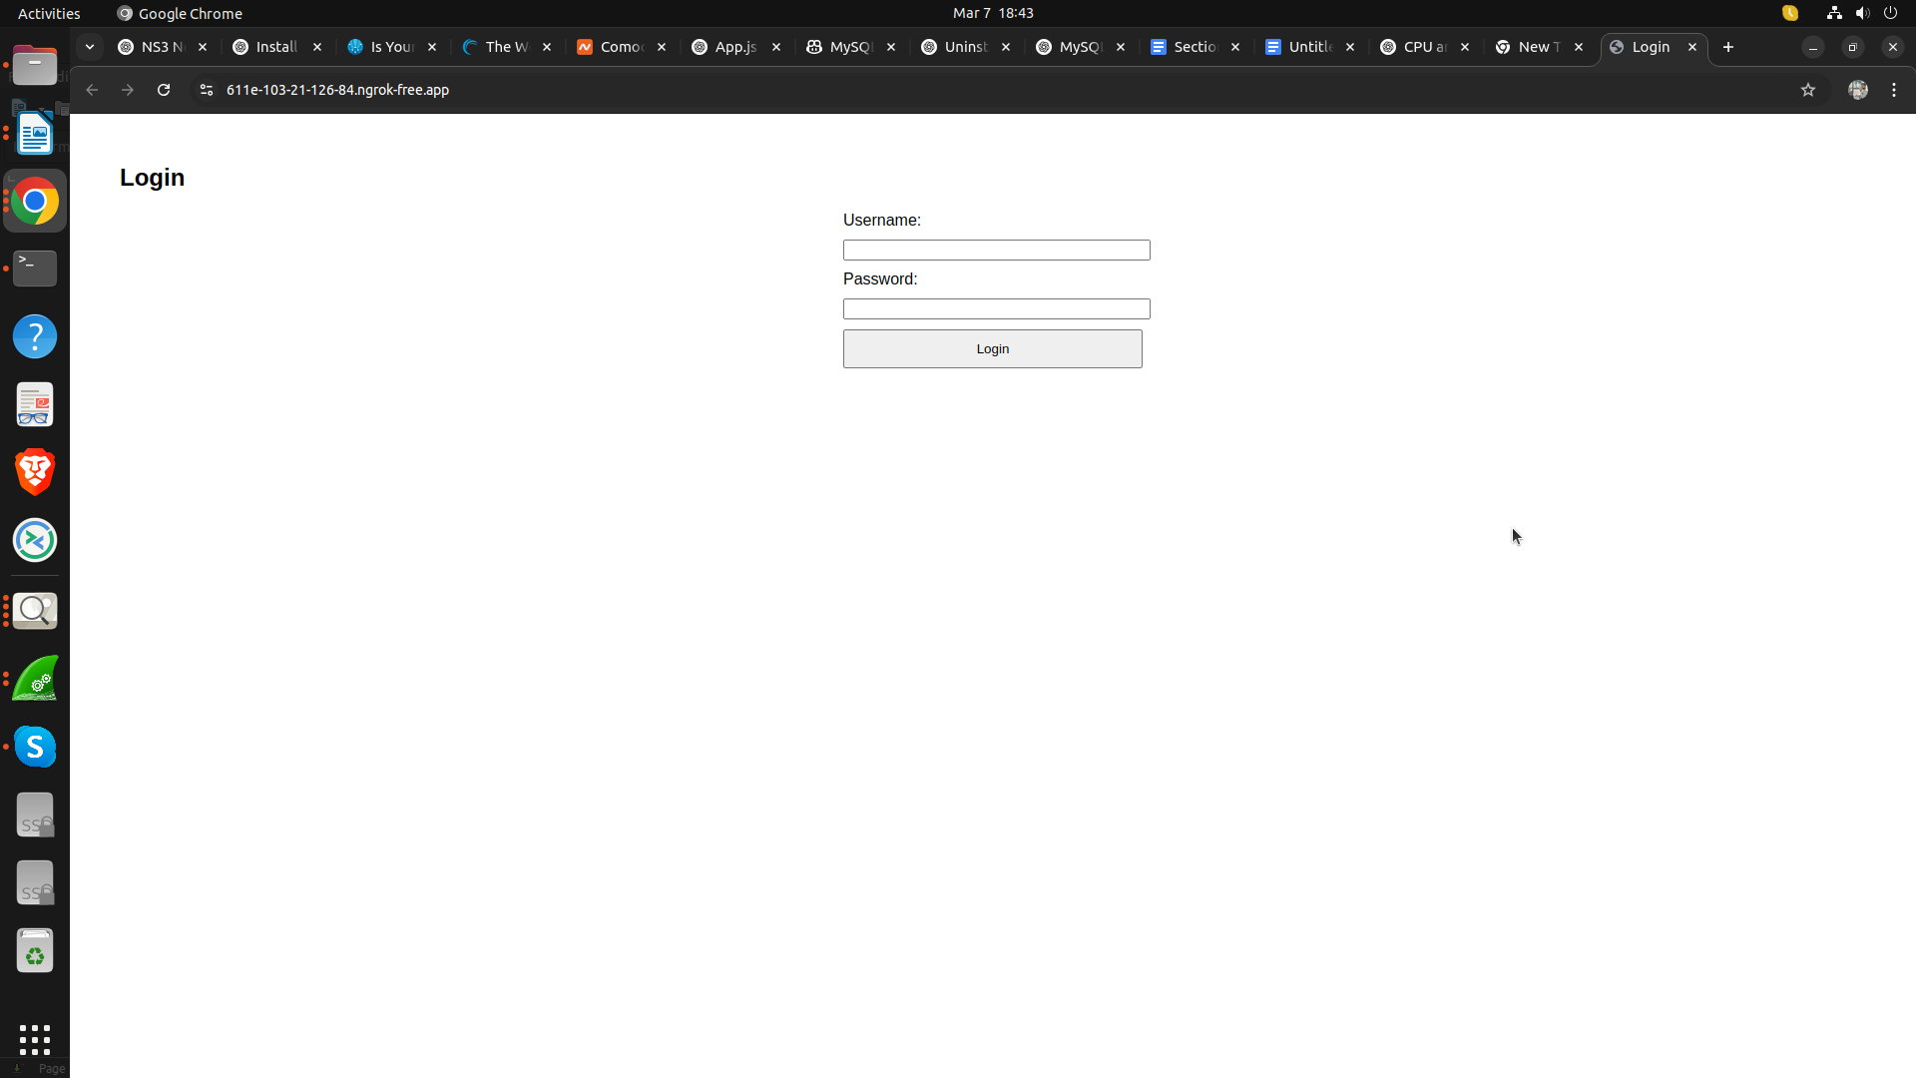

**Fig. 28 The screen outputs after running the Ngrok server on my localhost which assigned one public domain .And Our Public Domain is running Properly Running as like localhost**

For checking the NULL Cipher is disable or not We try to login in from Client (10.107.48.65) to check does Null Cipher is accepted Or rejected

**$ SHOW VARIABLES LIKE 'ssl_cipher';**

**$ SHOW STATUS LIKE 'Ssl_cipher';**

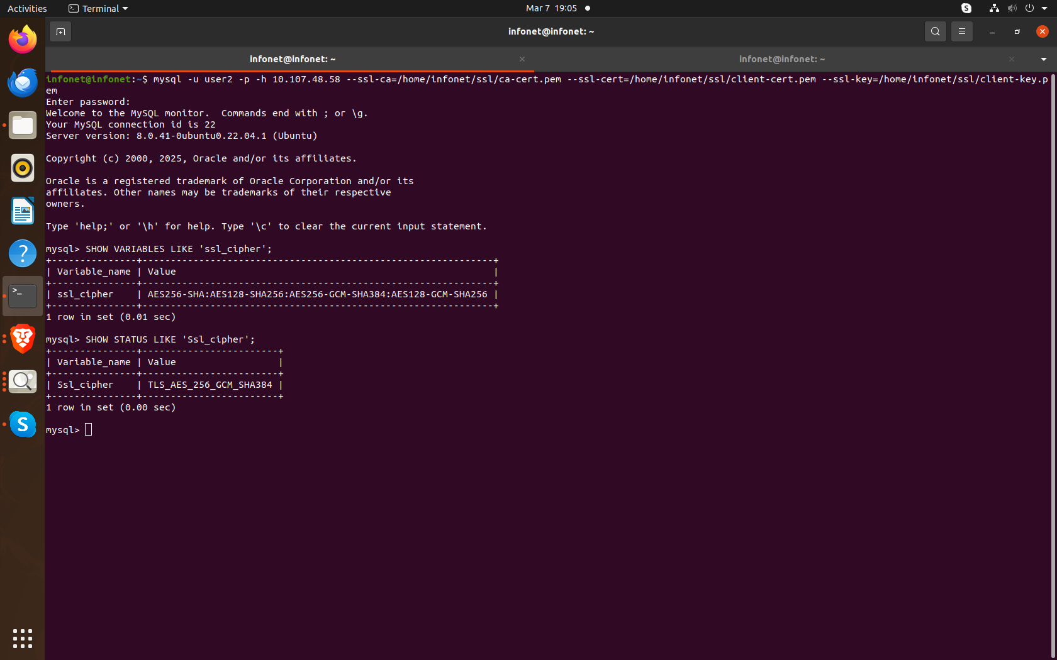

**Fig. 29 The screen DIsplay which Cipher is using in communication exchange between client and server**

We can Use **openssl command for testing that NULL Cipher** is disable or Not

Run the below Command for Testing that

**openssl s_client -connect 10.107.48.58:3000 -CAfile /home/infonet/ssl/ca-cert.pem -cert /home/infonet/ssl/client-cert.pem -key /home/infonet/ssl/client-key.pem -noservername**

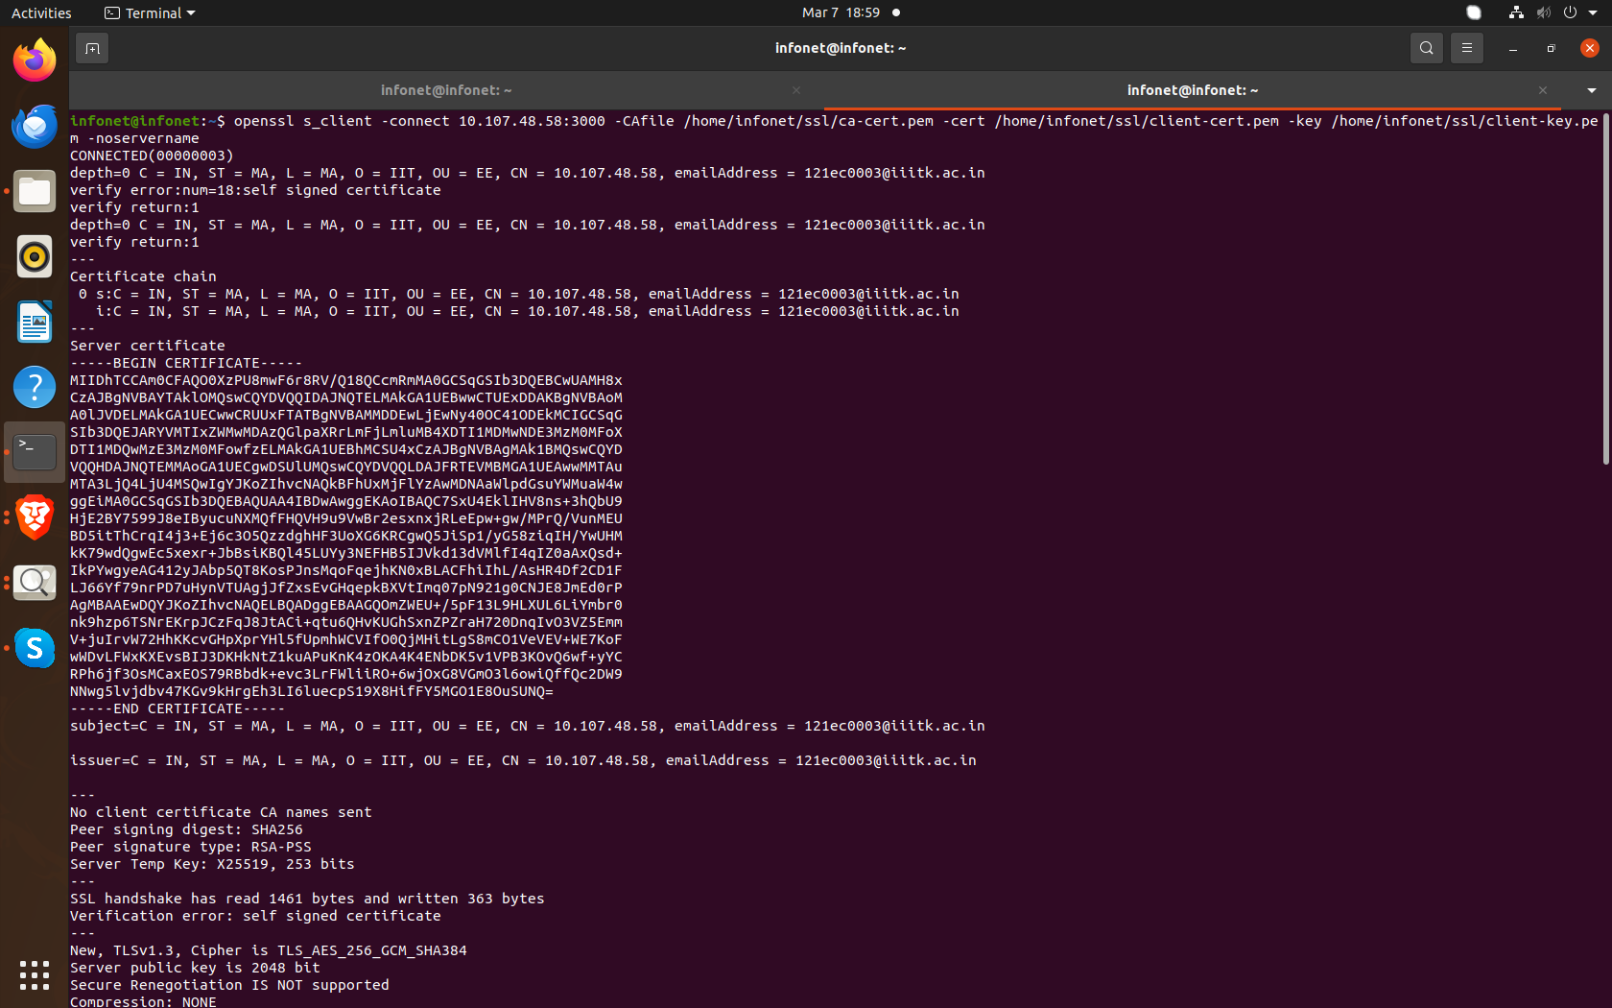

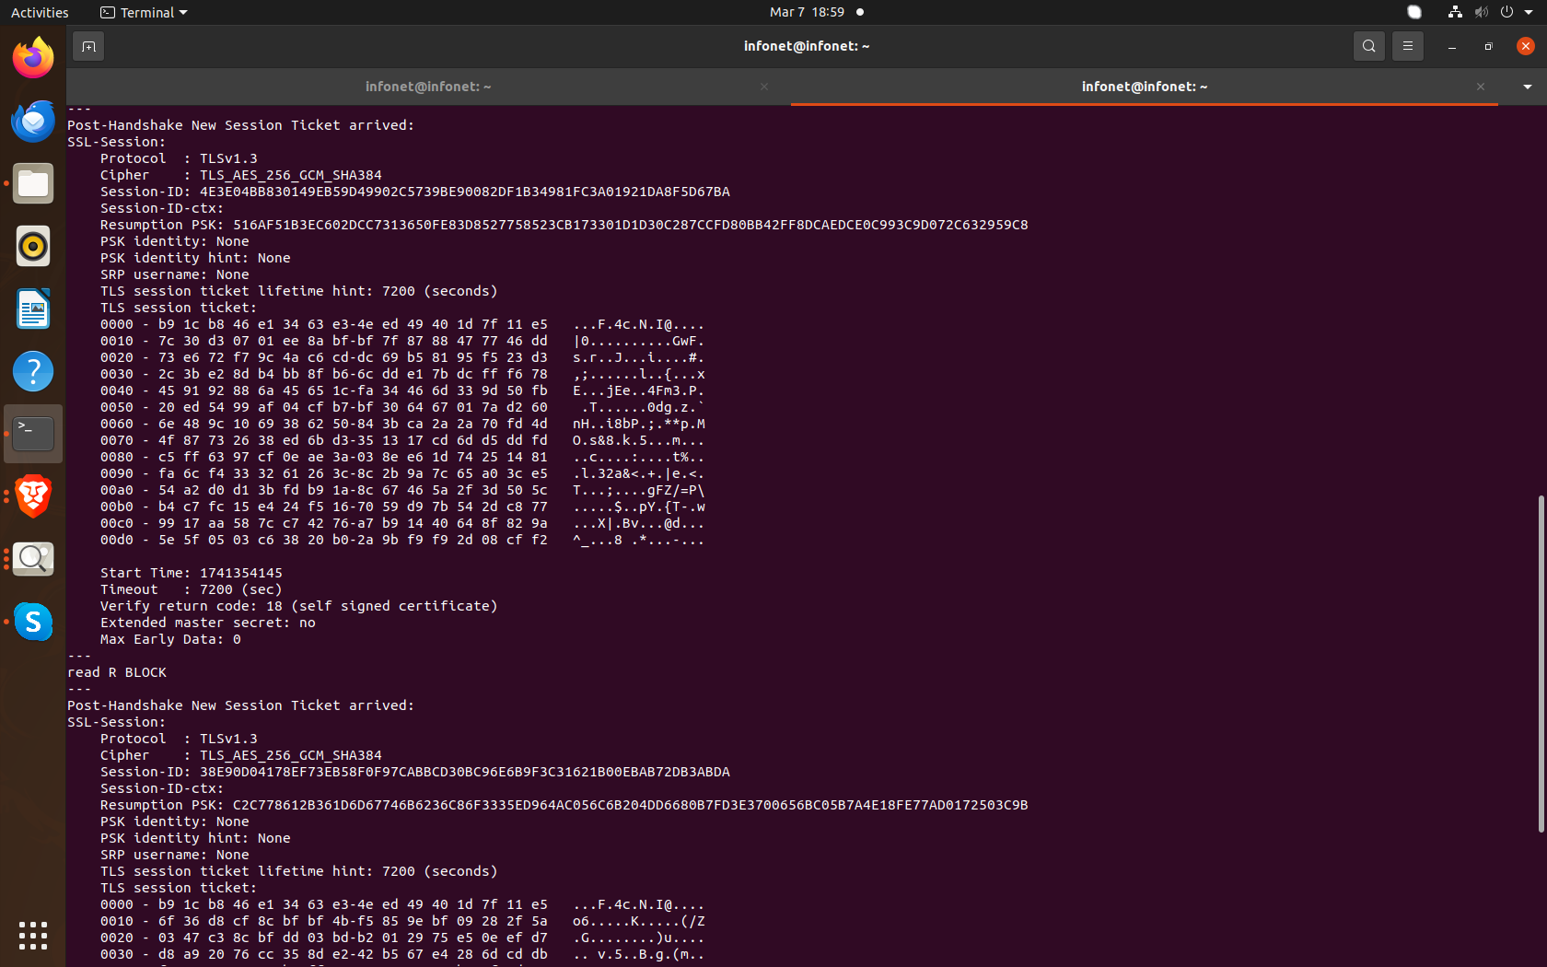

**Fig. 29 Handshaking on CLient using CA certificate client and server key**

From the output of the openssl s_client command, we can see that the connection to the server is using the **TLS_AES_256_GCM_SHA384** cipher. This means that the **NULL cipher is not being used for the connection**.

We can verify TLS handshake, using Curl

By running the below command

**$ curl -v --cert /home/infonet/ssl/client-cert.pem --key /home/infonet/ssl/client-key.pem --cacert /home/infonet/ssl/ca-cert.pem -k https://10.107.48.58:3000**

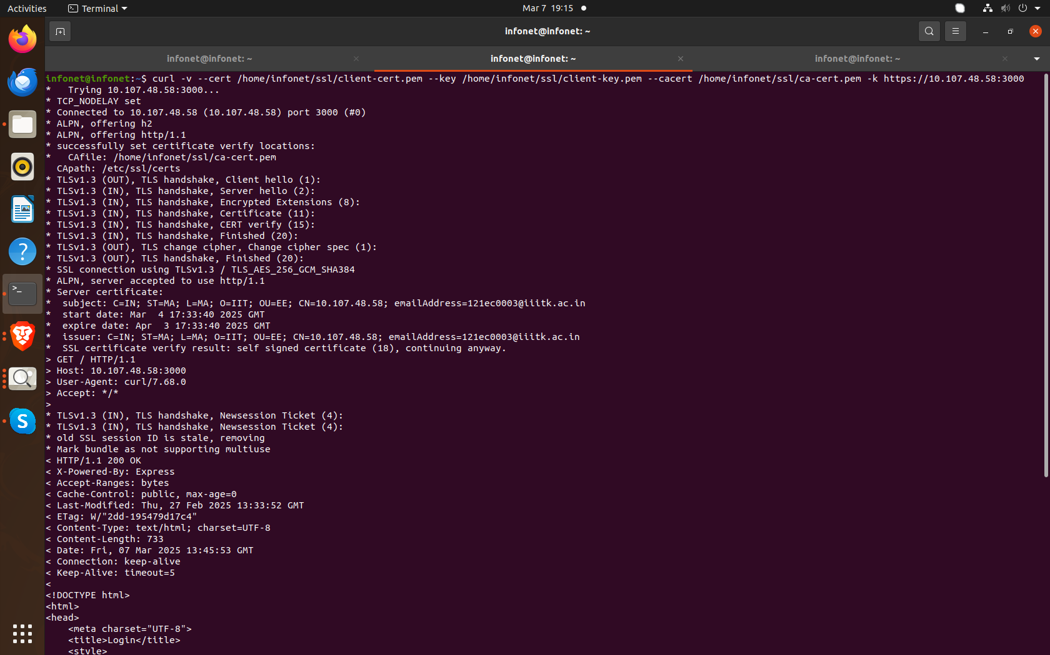

**Fig. 30: The image shows the output of a curl command making a secure HTTPS request with client-side certificates, detailing the connection process and server response.**

For IKE and IPsec, the tester shall base the tests on the profile defined by 3GPP in TS 33.210 [9] and TS 33.210 [15]. For IKE and IPsec, the tester shall base the tests on the profile defined by 3GPP in TS 33.210 [15].For protocols, for which 3GPP did not define a security profile, e.g. SSH, the tester shall base the tests on a widely recognised and publicly available security profile (e.g., security profile defined by IETF or NIST).

Execution Steps

1. The tester shall check that compliance with the selected security profile can be inferred from detailed

provisions in the product documentation.

2. The tester shall check that the default security parameters are the same as those stated in the product

documentation.

3. The tester shall establish a secure connection between the network product and the peer and verify that all protocol versions and combinations of cryptographic algorithms that are mandated by the security profile are supported by the network product and the network product does not use the deprecated or unsecure protocol versions and algorithms.

4. The tester shall try to establish a secure connection between the network product and the peer and verify that this is not possible when the peer only offers a feature, including protocol version and combination of cryptographic algorithms, that is forbidden by the security profile.

Expected Results:

The traffic is properly protected, and insecure options are not accepted by the Network Product.

Expected format of evidence:

Provide evidence of the check of the product documentation in plain text. Save the logs and the communication flow in a .pcap file.

SO FIrst we have to check the check if **IPsec tunnels** are active:

We can Run the following command

$ sudo ipsec status



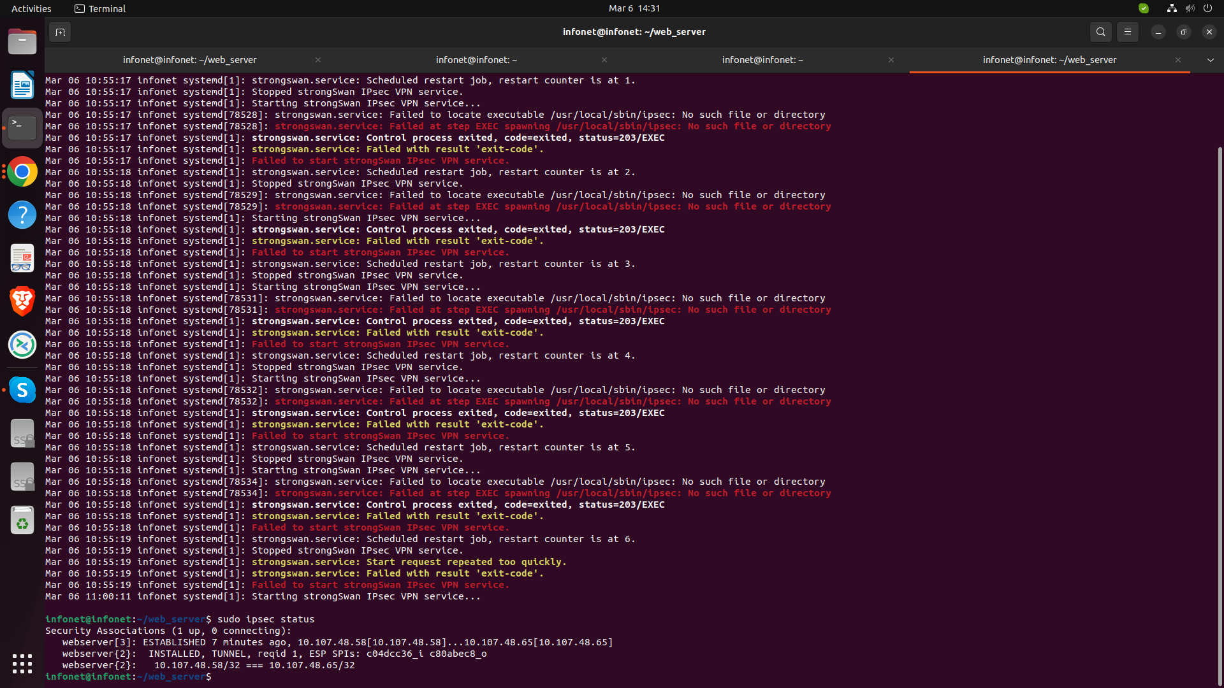

**Fig. 31: The image shows the IPsec is active, you should see Security Associations (SAs) with encryption details.**

Checking the **Internet Key Exchange Version**

$ sudo ipsec statusall

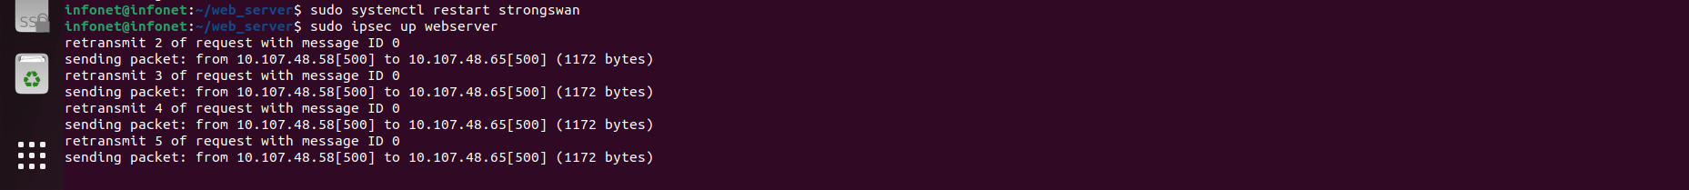

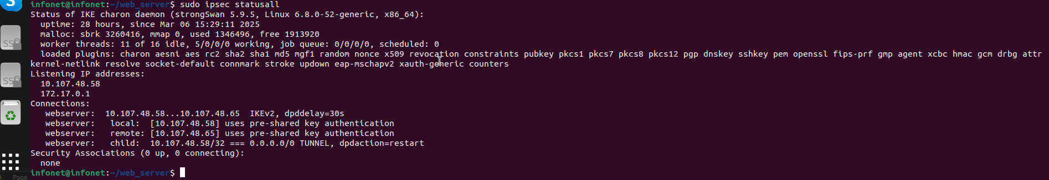

**Fig. 32: This image shows the status and detailed information of the IKE charon daemon from executing the sudo ipsec statusall command in a terminal**

### **Verify if StrongSwan is activate it confirm IPsec/IKE usage.**

systemctl status strongswan

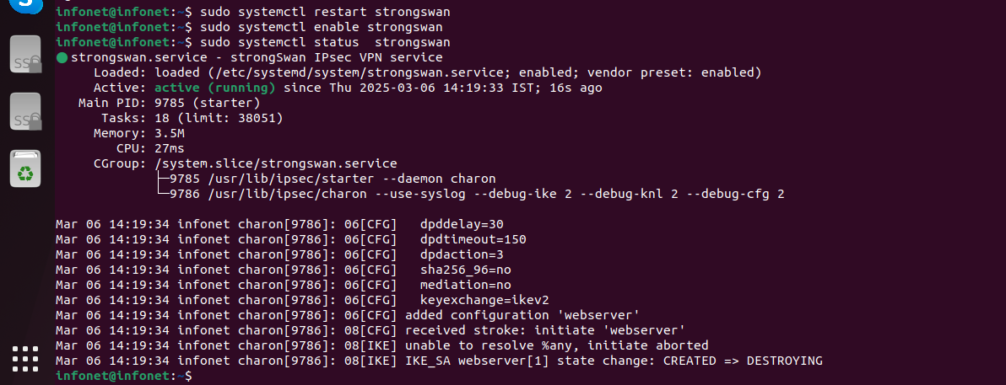

**Fig. 33: This image shows the Status of Strongswan**

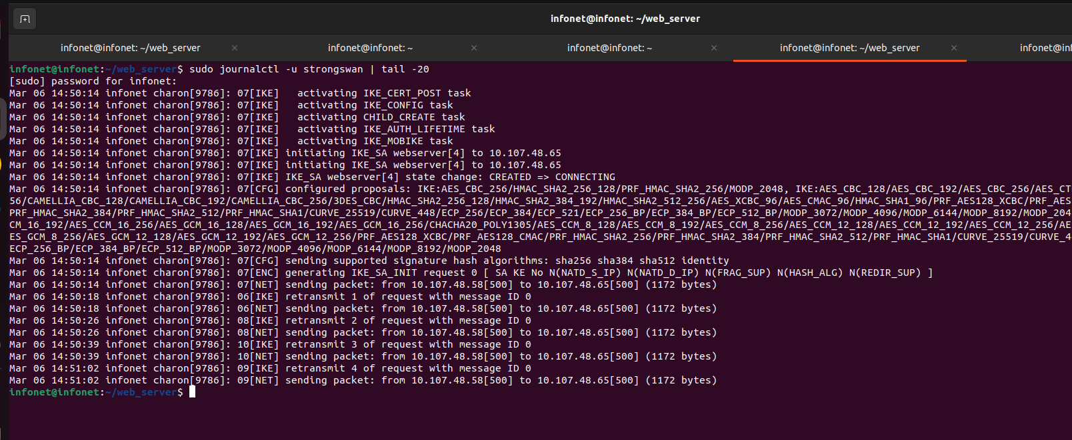

**Fig. 34: This image shows the status and details of the strongSwan VPN service, focusing on recent log entries.**

To View the IPsec configuration file:

Run the below command

$ cat /etc/ipsec.conf

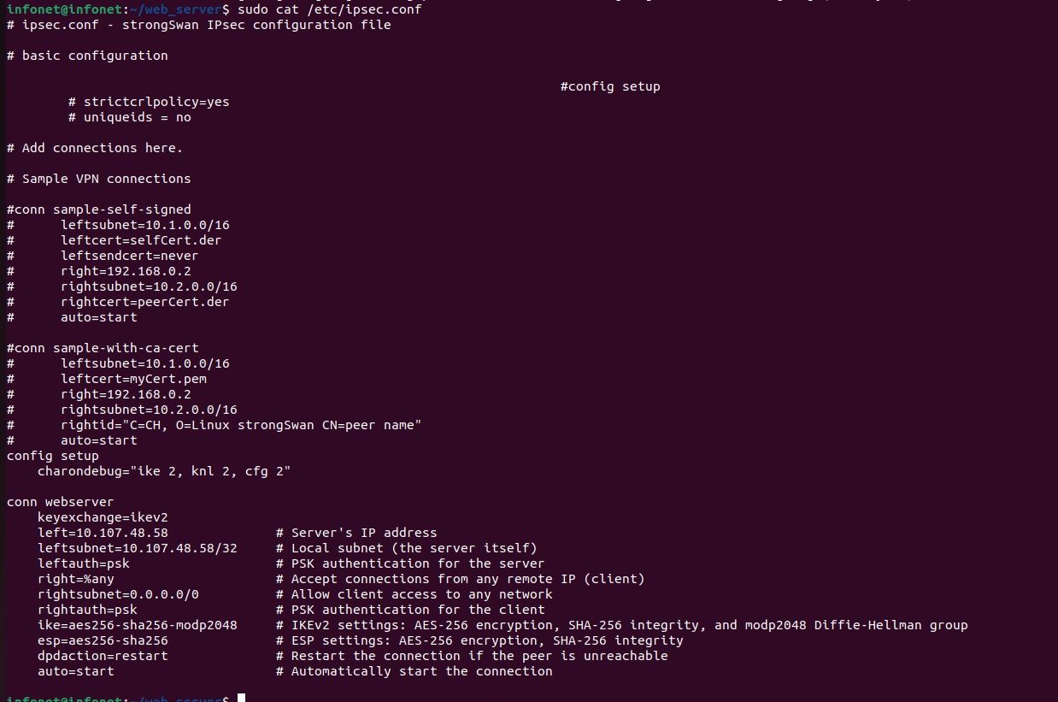

**Fig. 35: This image shows the IPsec configuration file.**

### **TO View the Active Connections which show the** active **IPsec/IKE sessions**

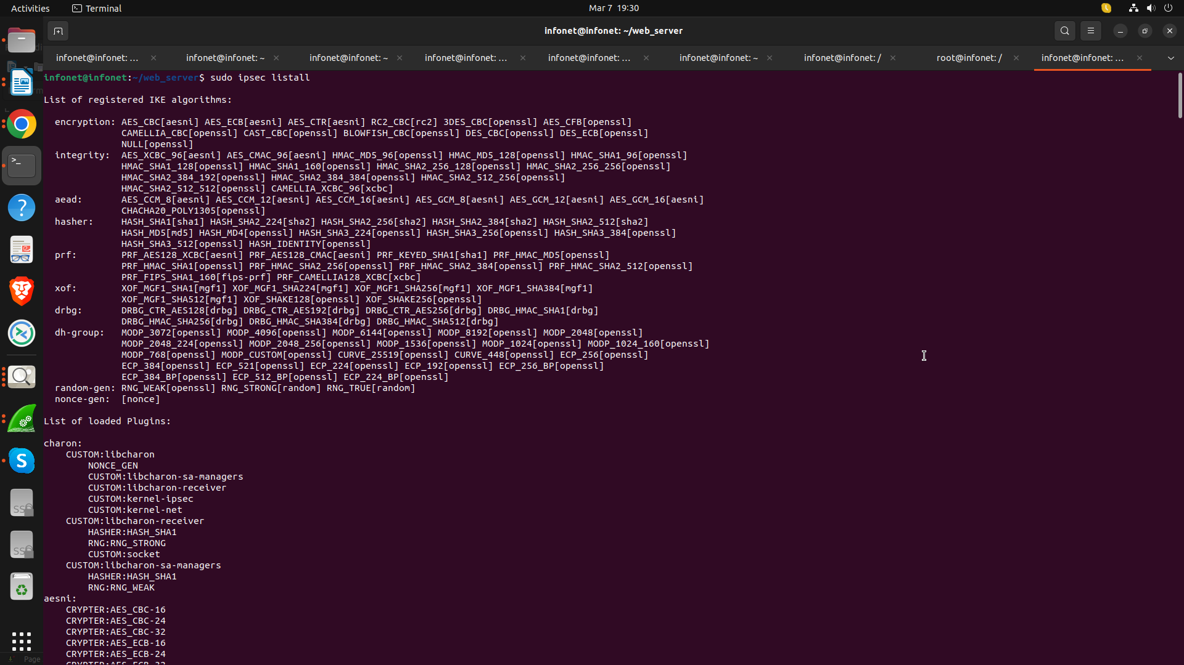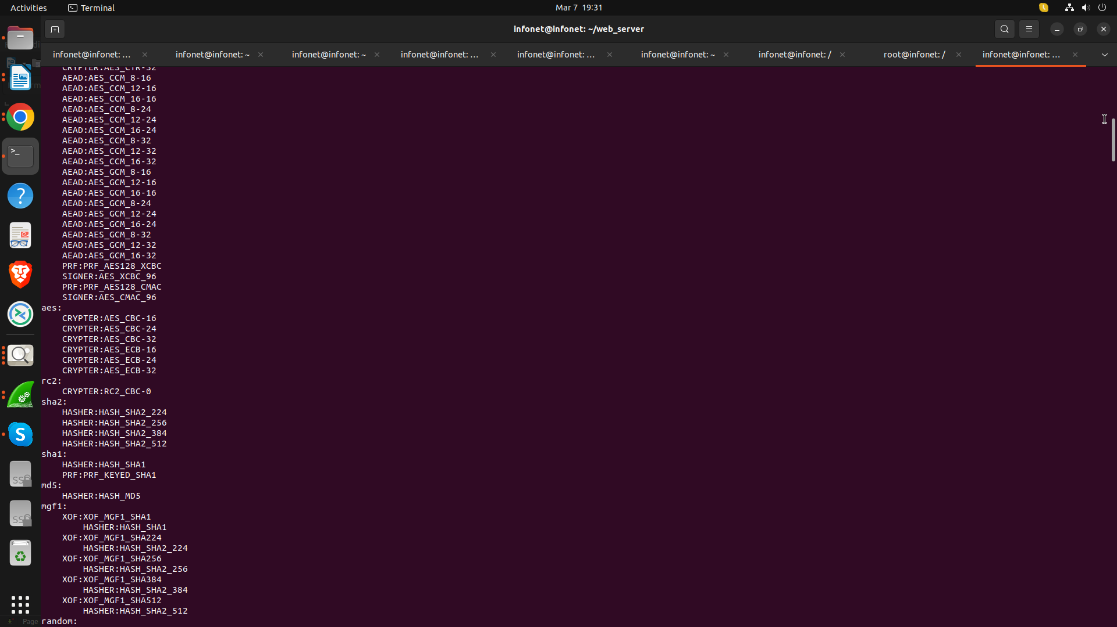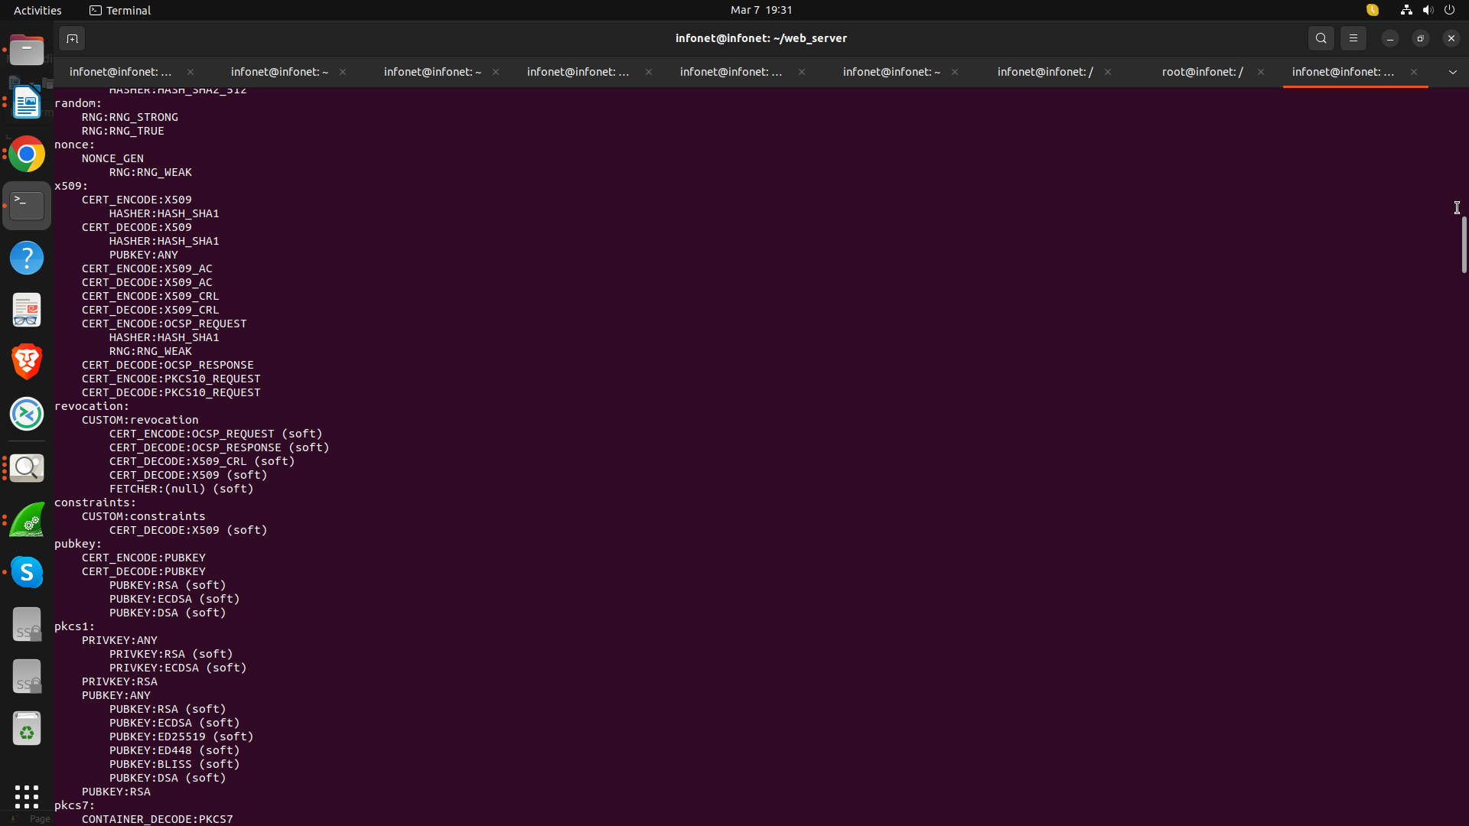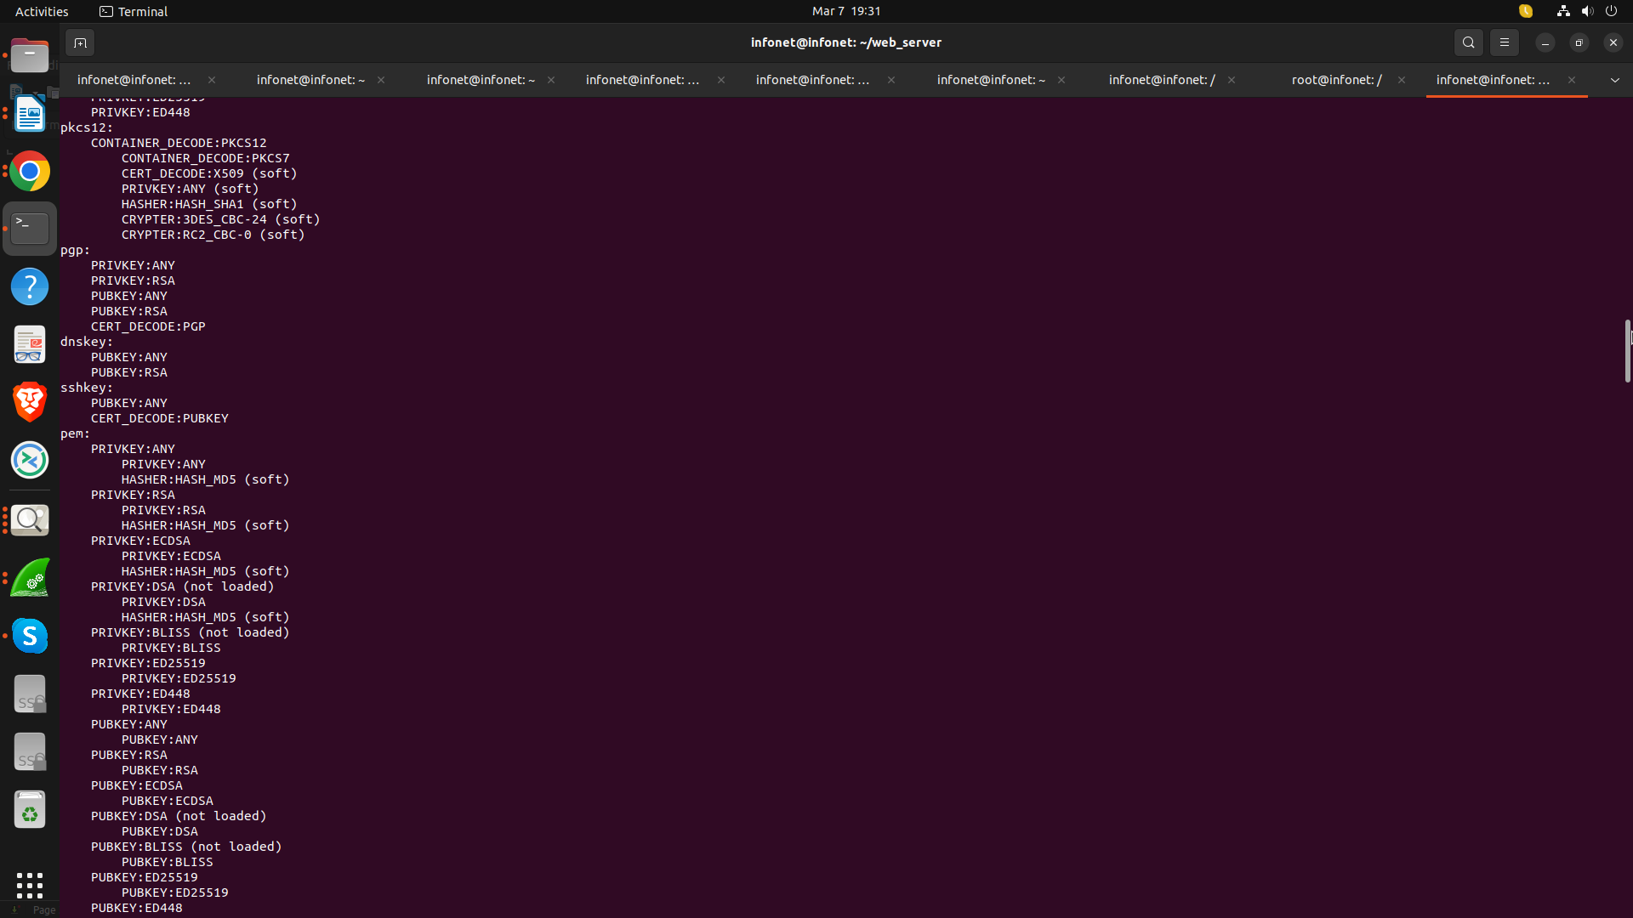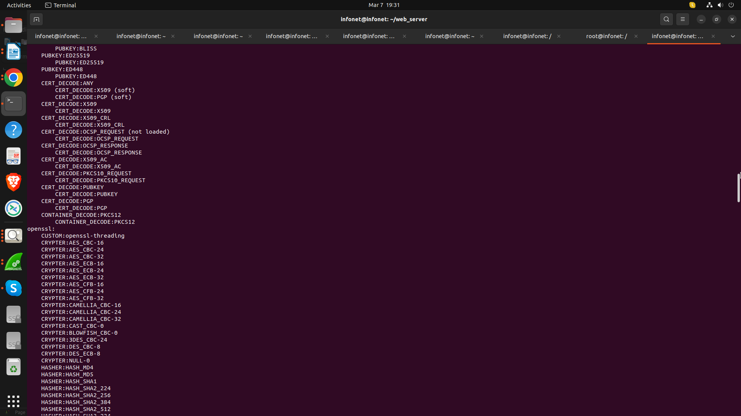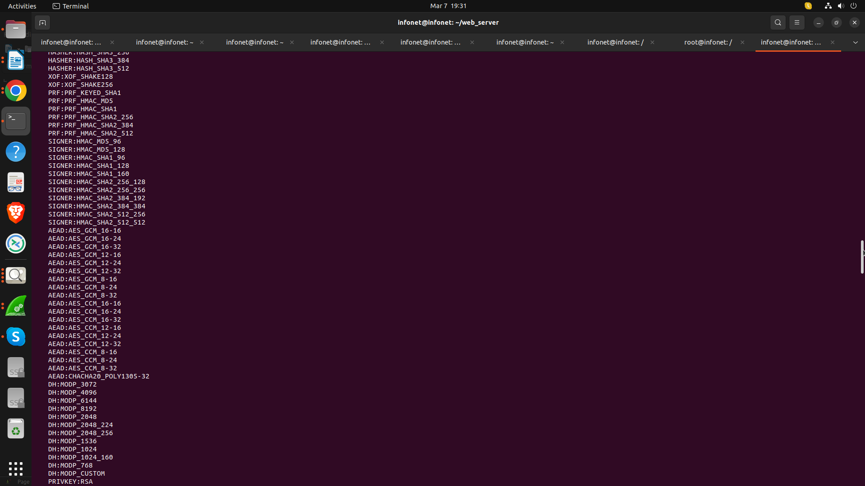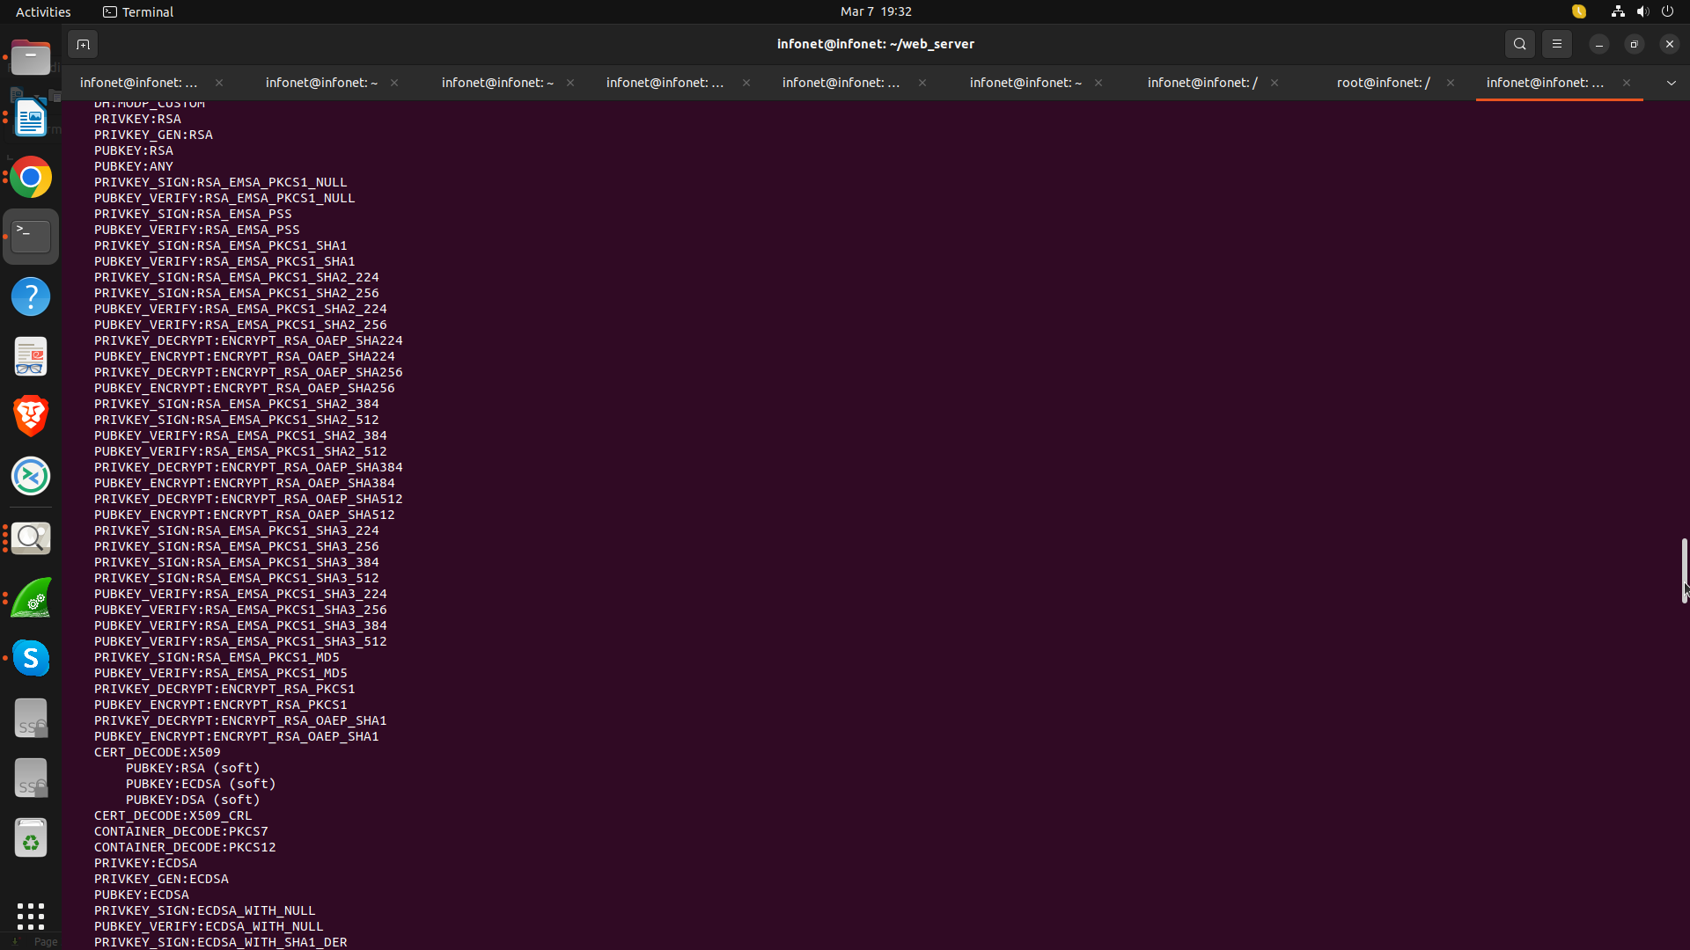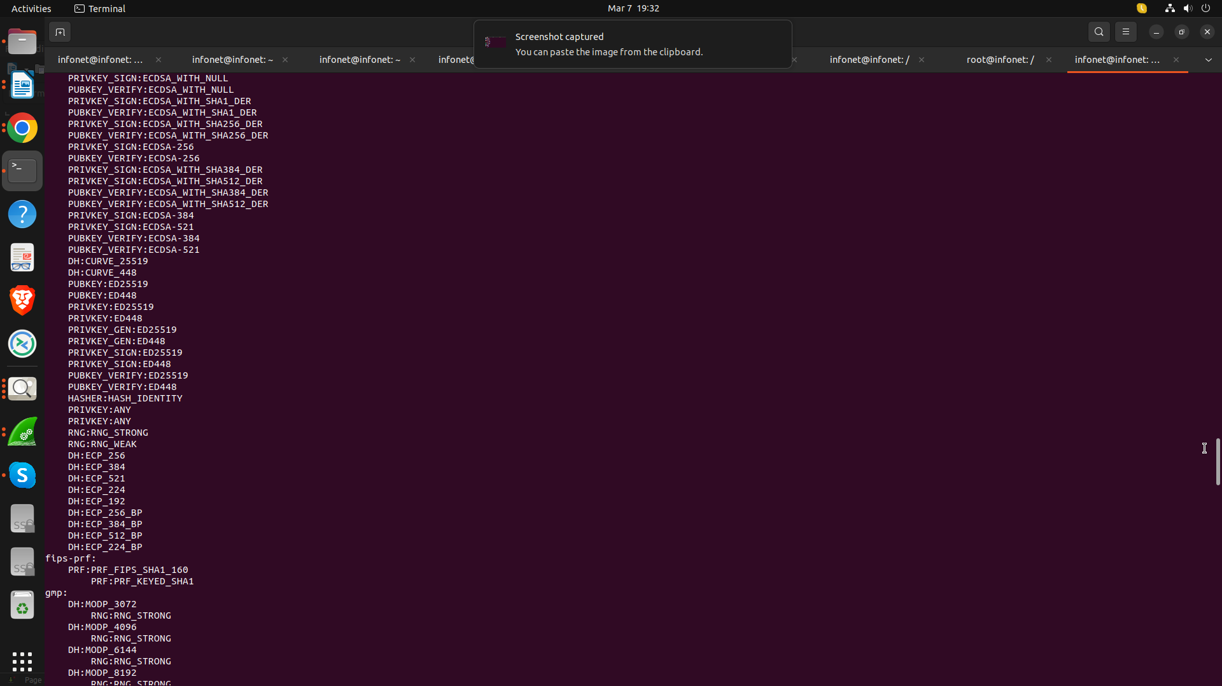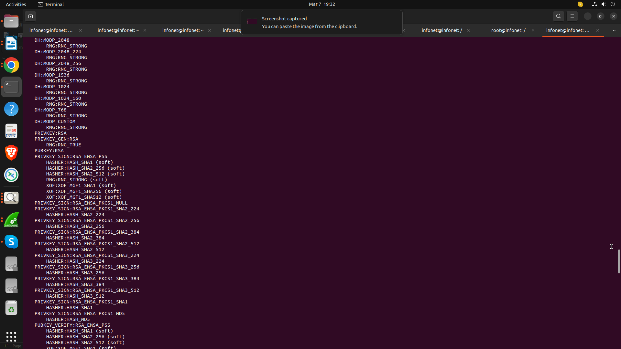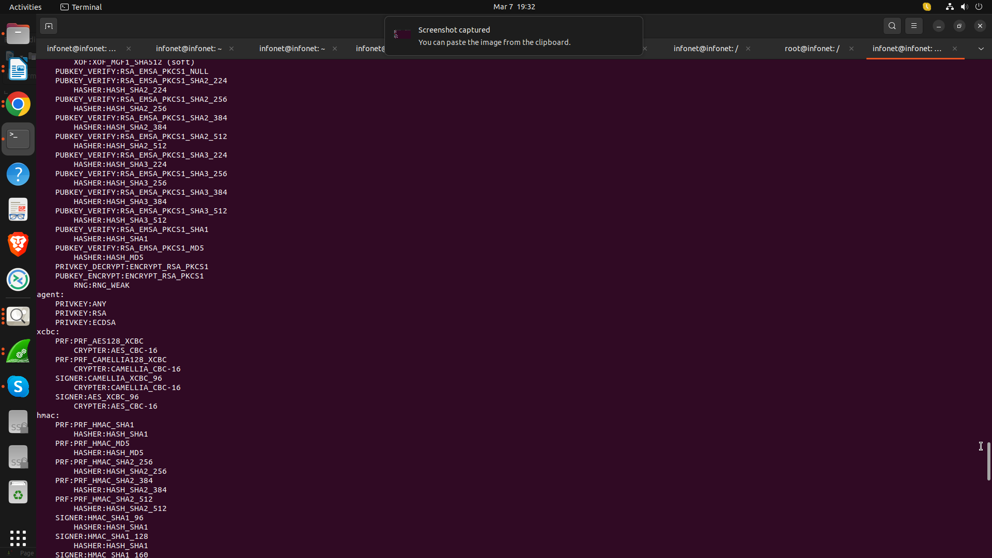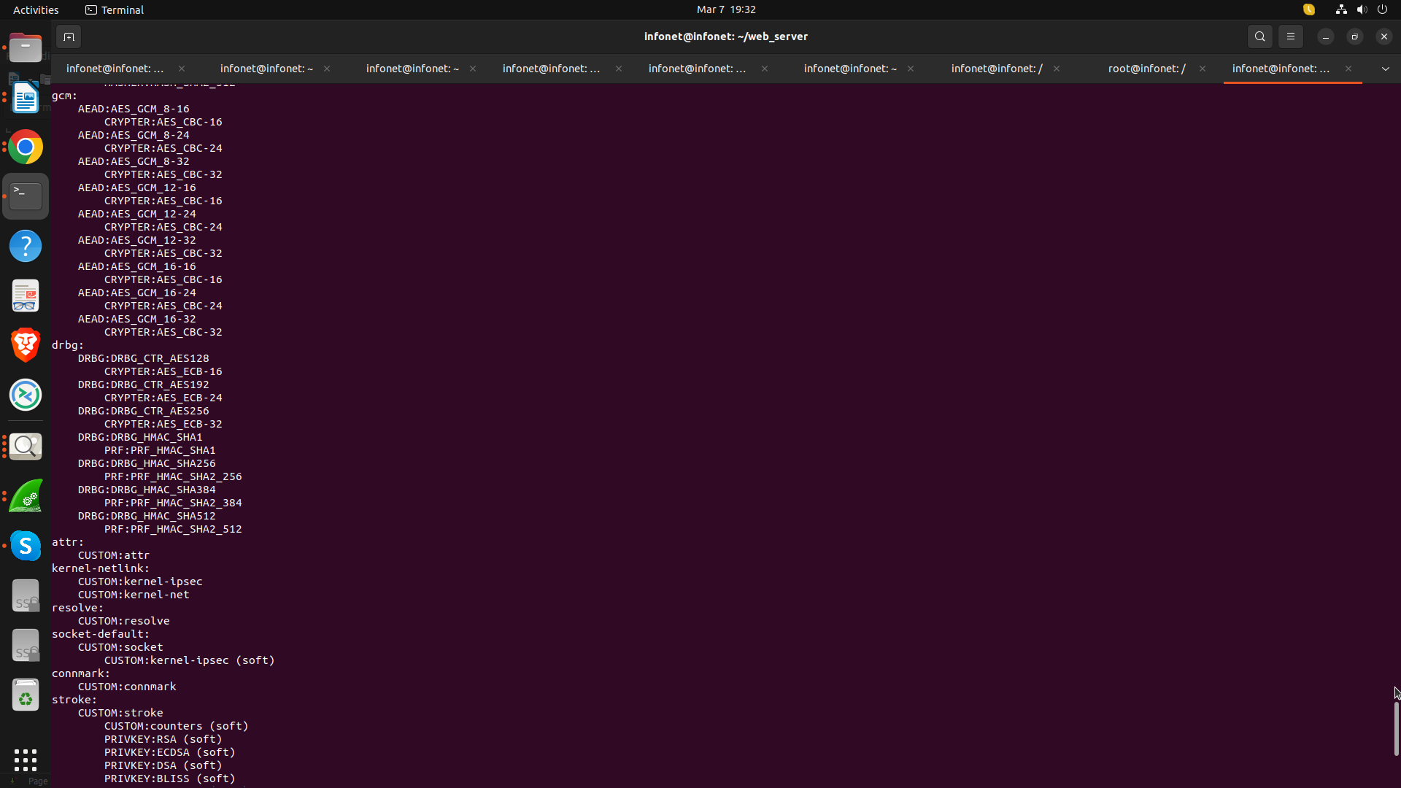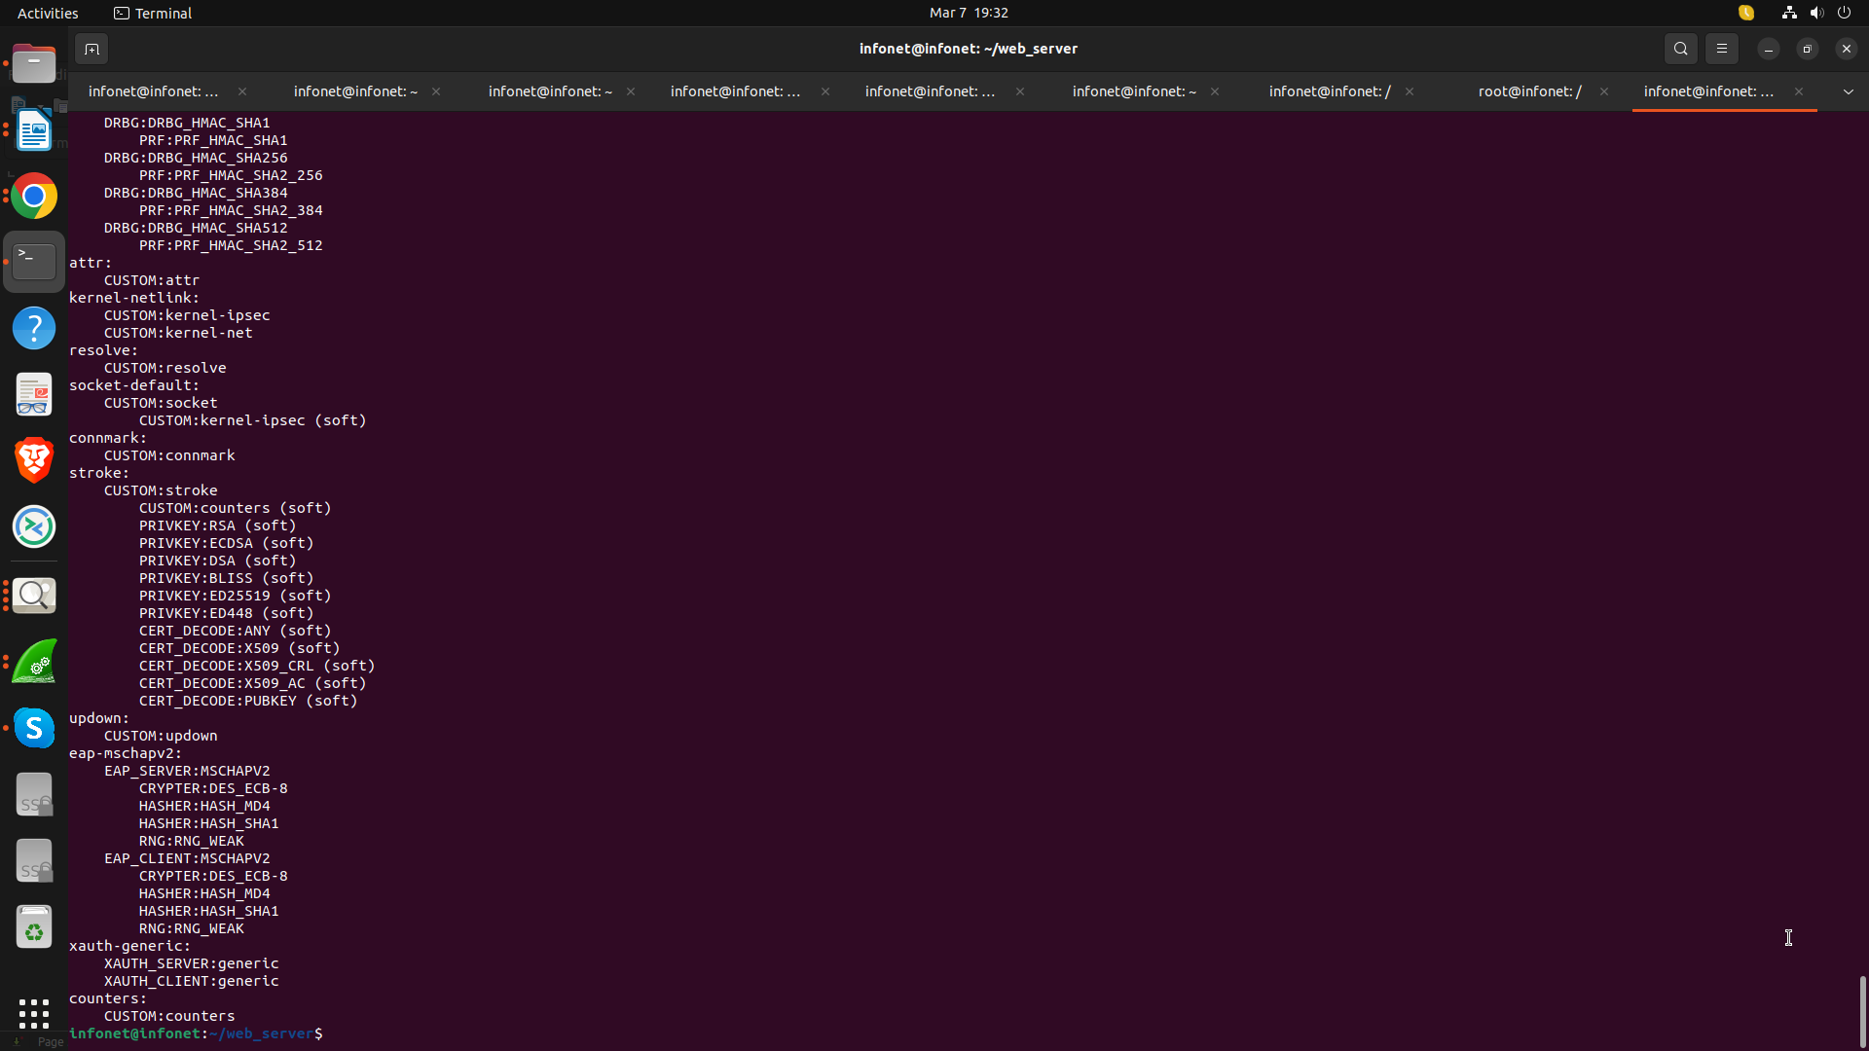

**Fig. 36: This image shows the Active Connections which show the active IPsec/IKE sessions**

